1. Write a JCL to create a sequential data set using **IEFBR14**.

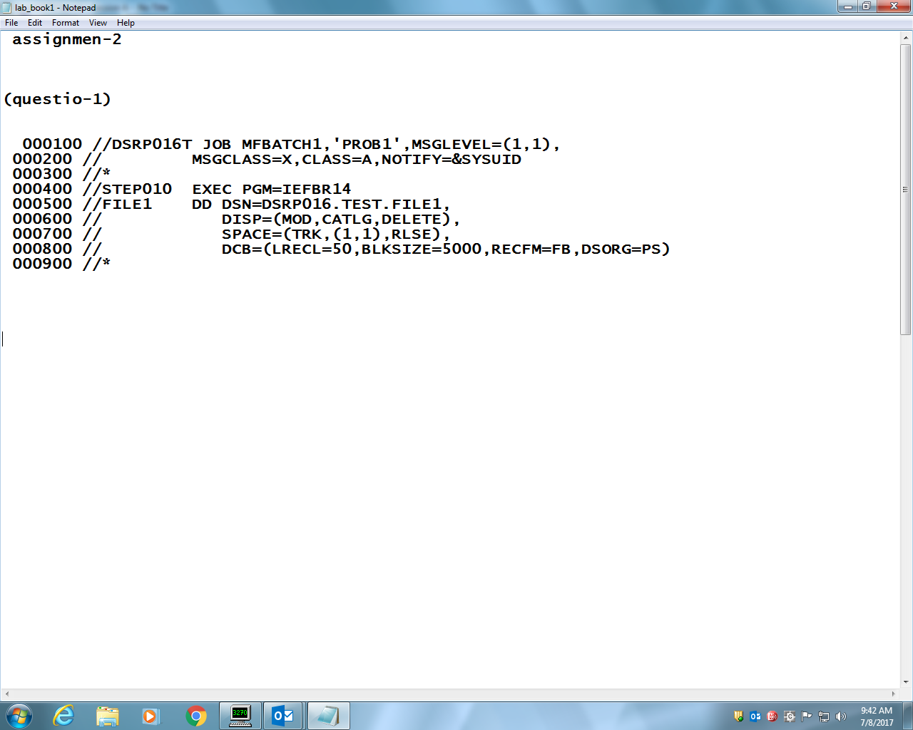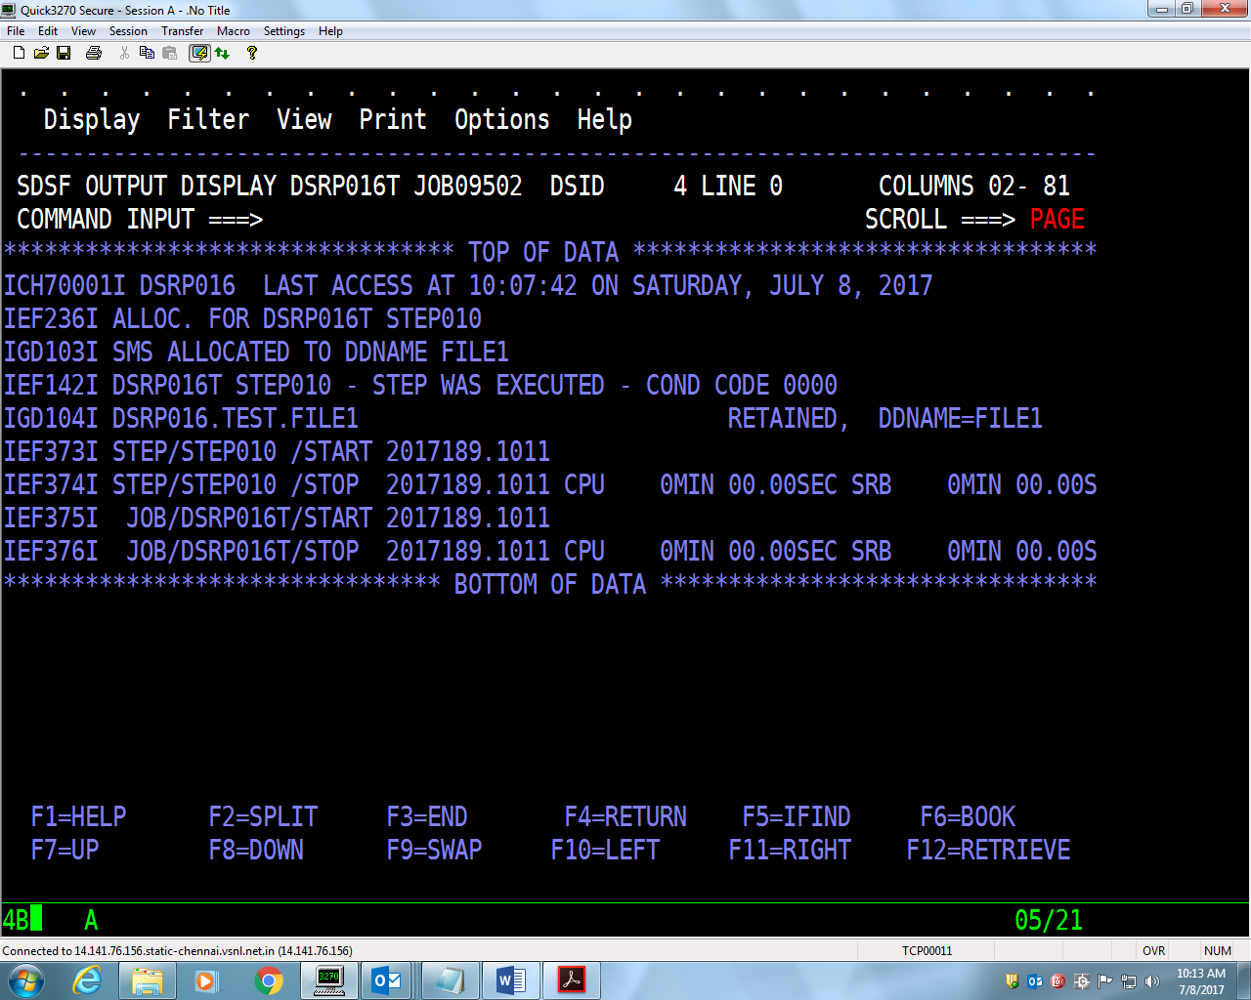

2. Write a JCL to delete a sequential data set using **IEFBR14**

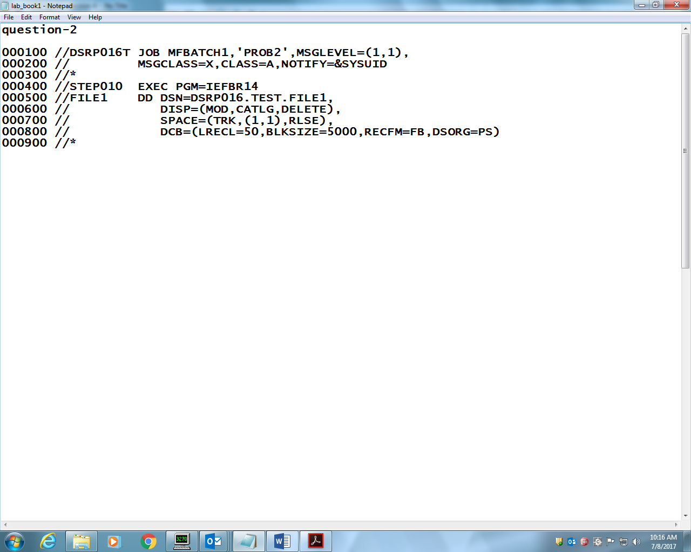

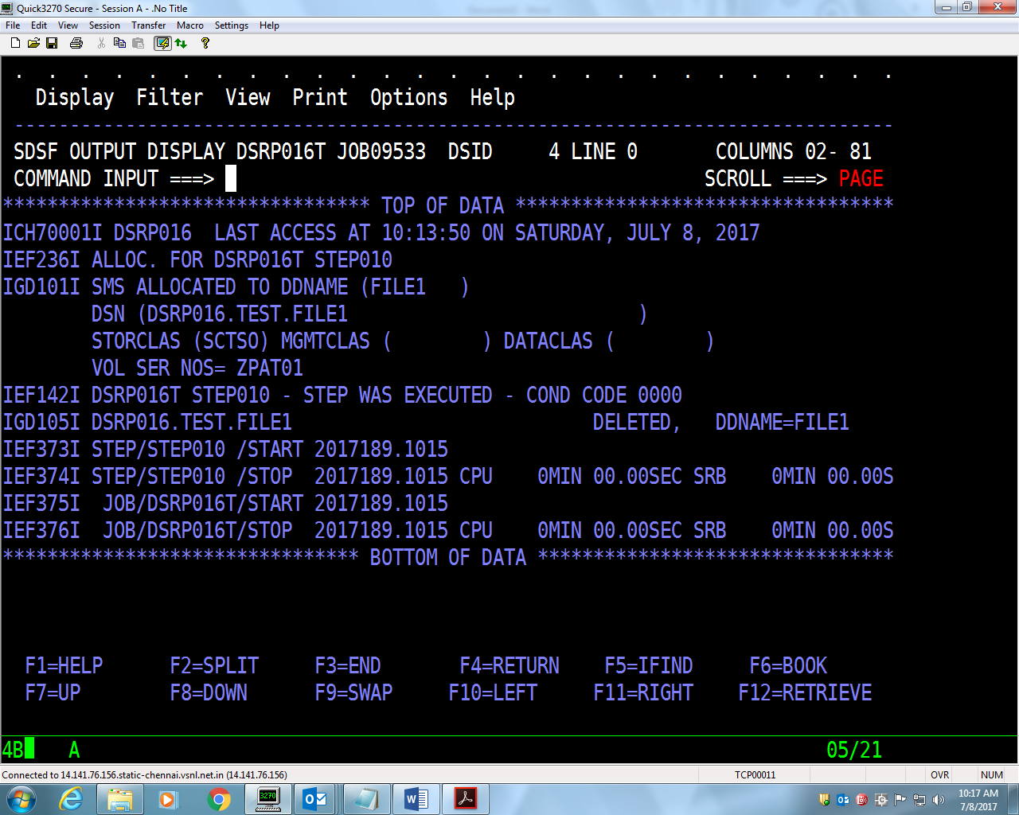

3. Write a JCL for **IEBGENER** to copy from **EMPFILE** into another. Try out all the

JCLs given in the handout.(METHOD1)

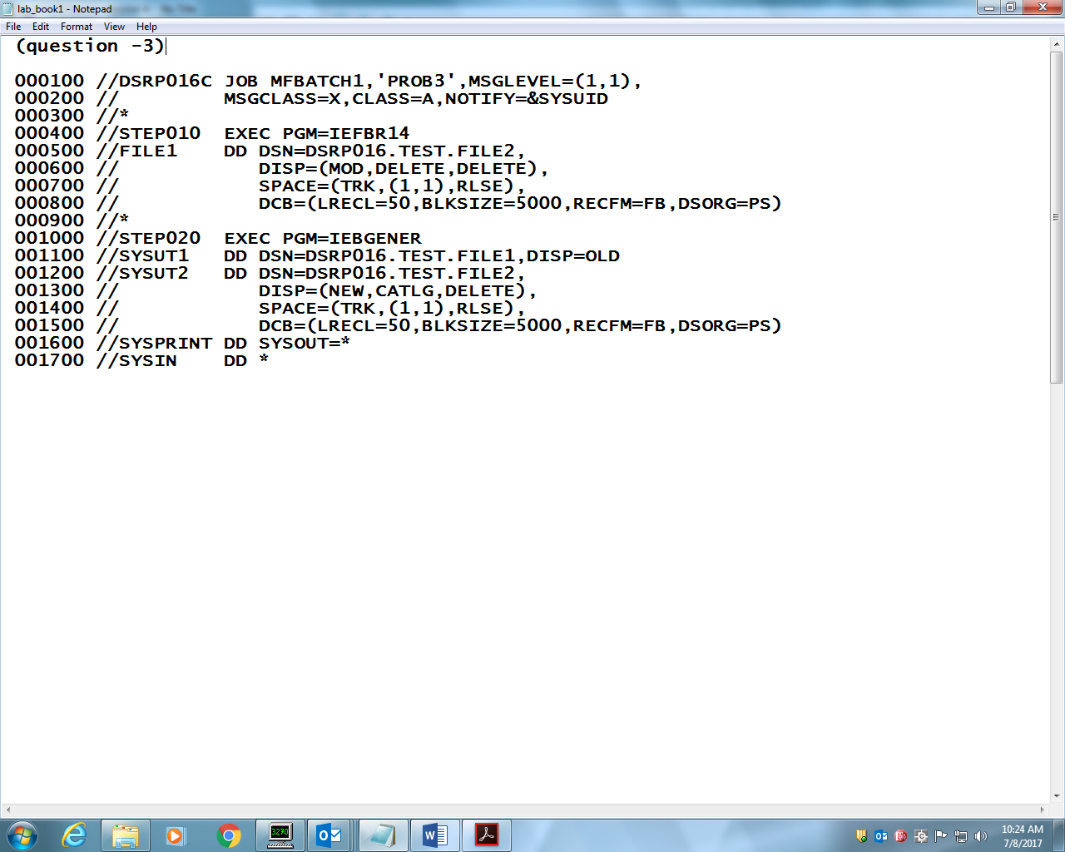

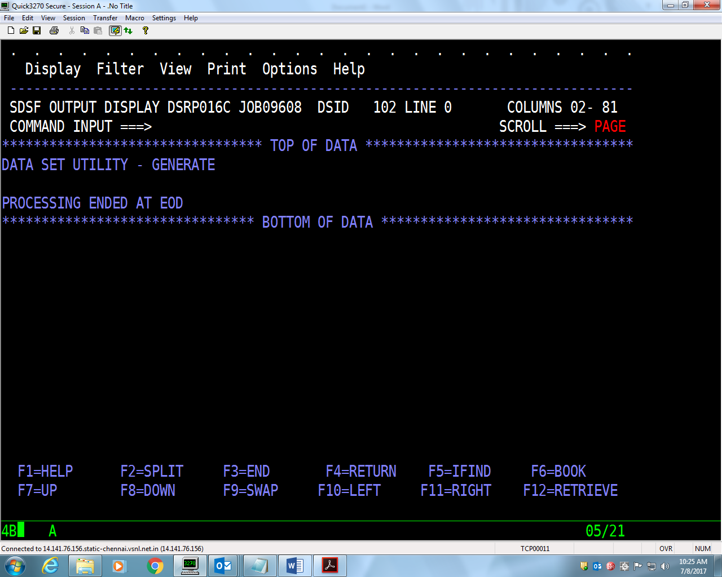

3. Write a JCL for **IEBGENER** to copy from **EMPFILE** into another. Try out all the

JCLs given in the handout.(method2)

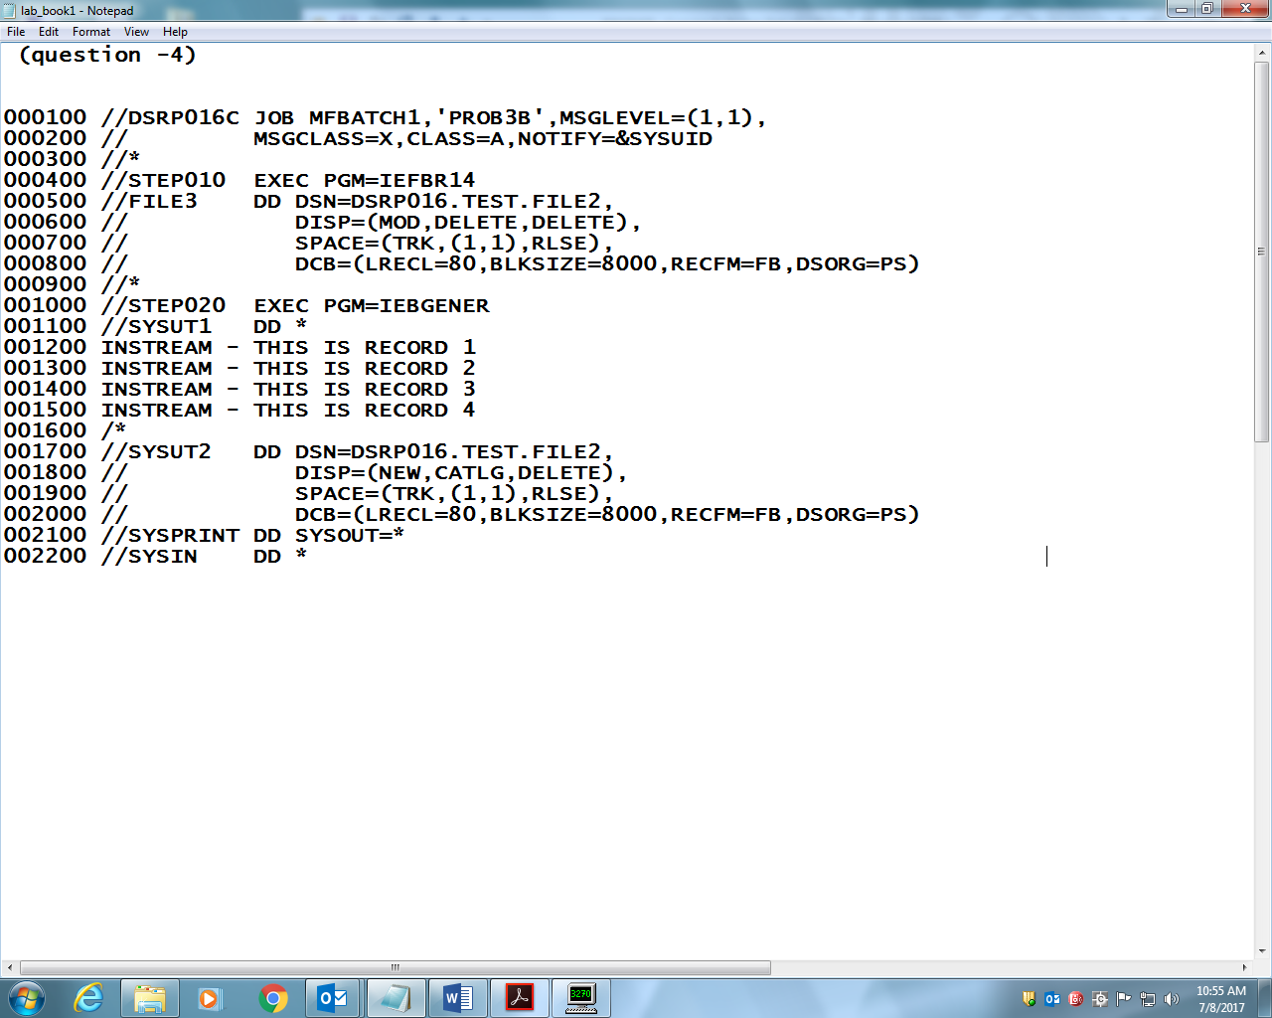

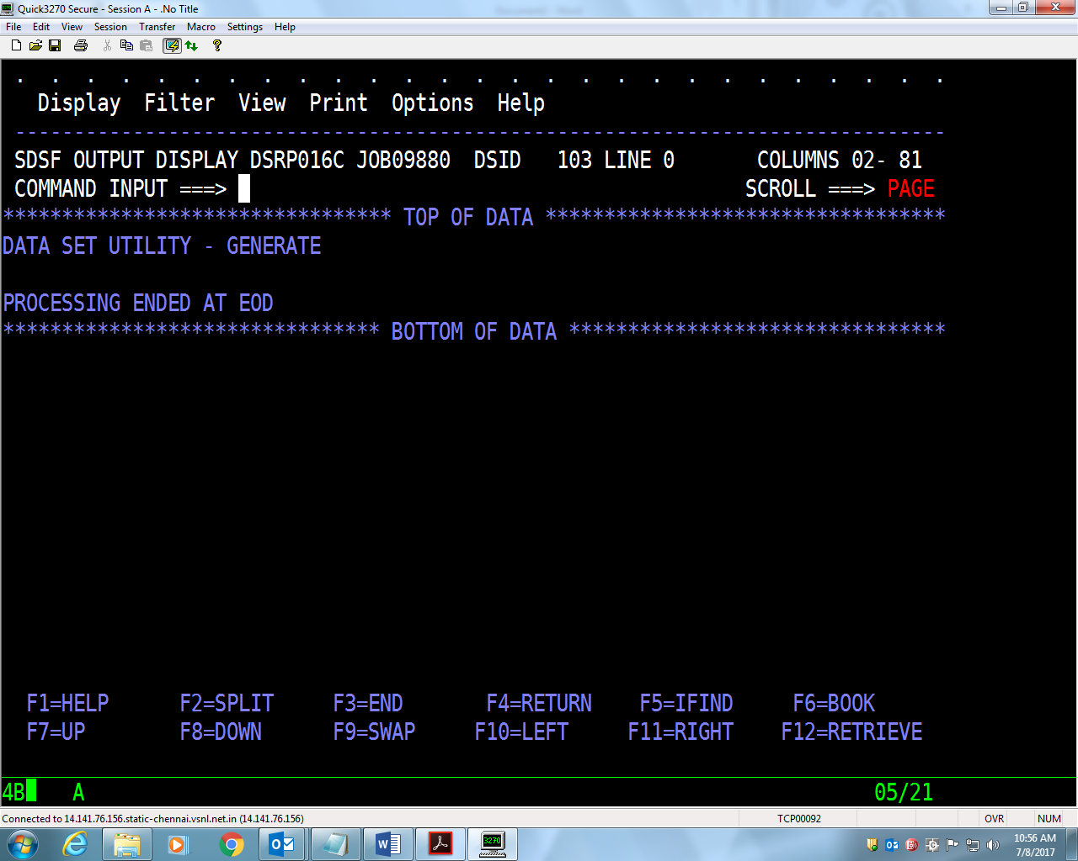

3. Write a JCL for **IEBGENER** to copy from **EMPFILE** into another. Try out all the

JCLs given in the handout.(method3)

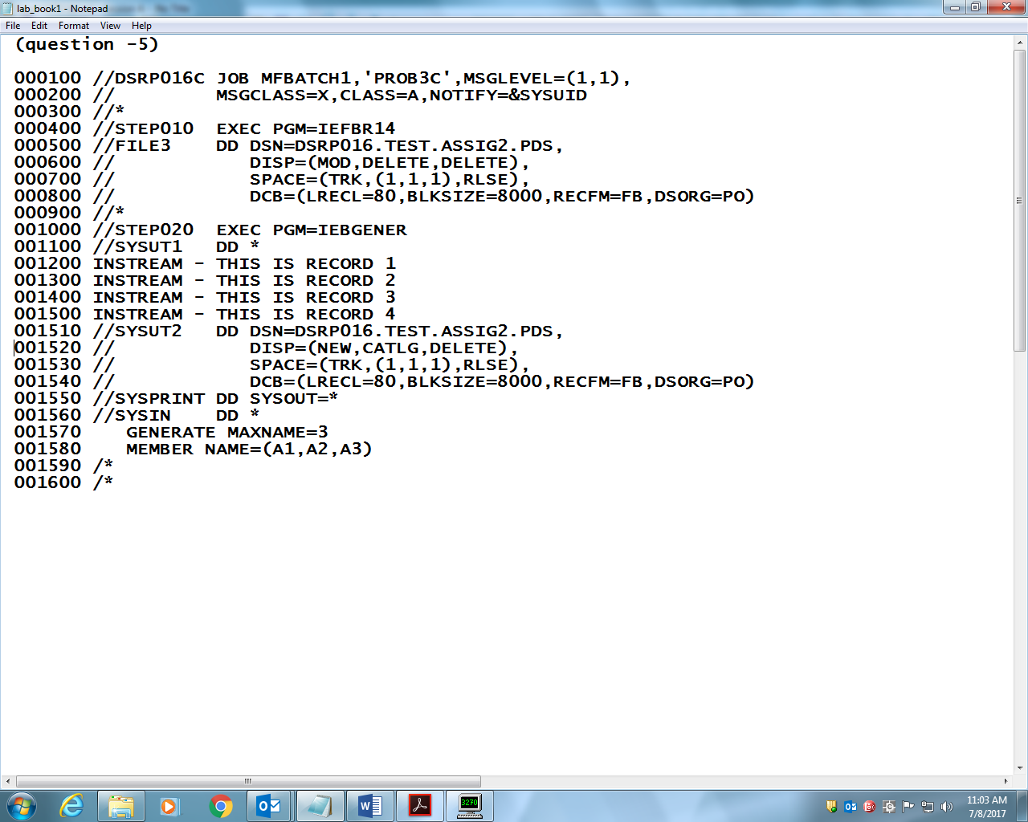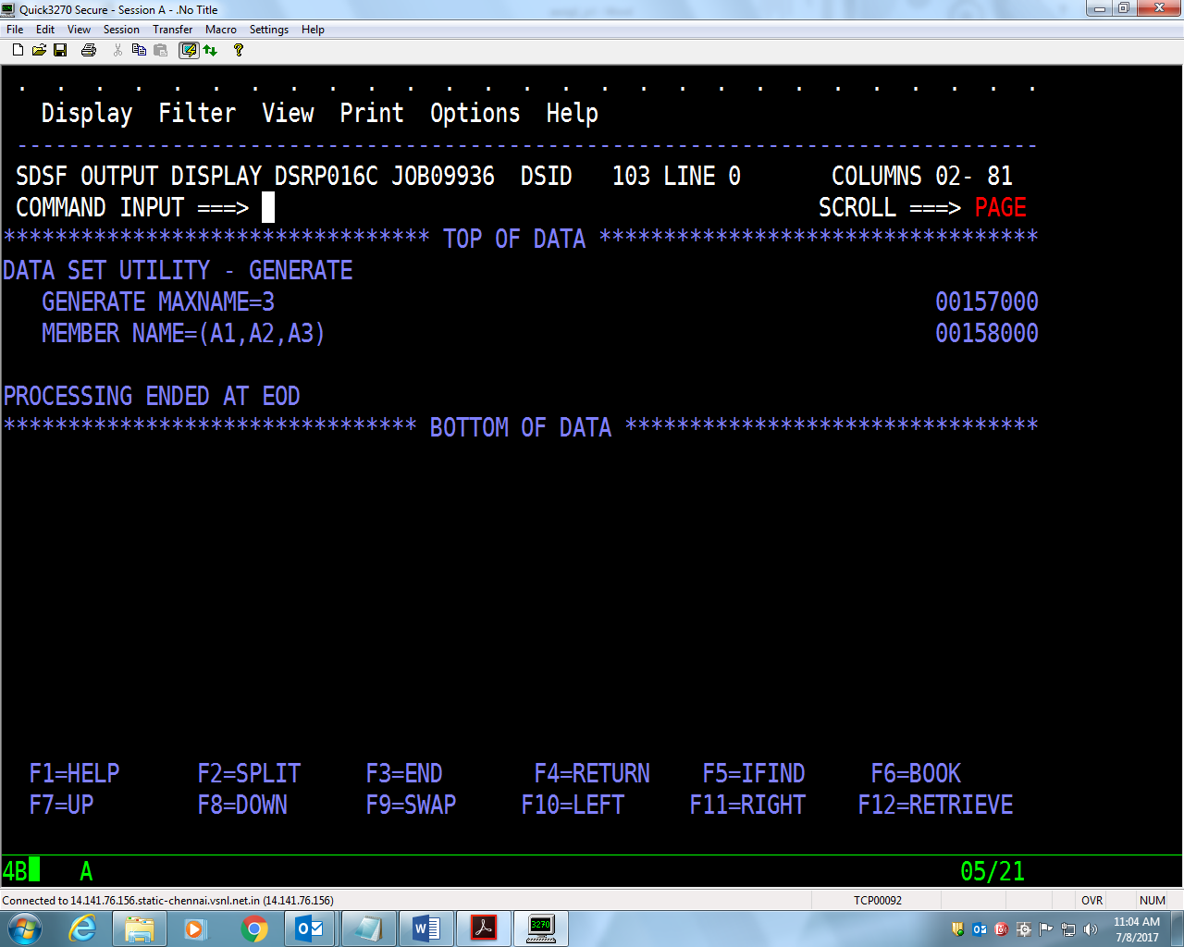

4. Try concatenation of sequential files using **IEBGENER**.

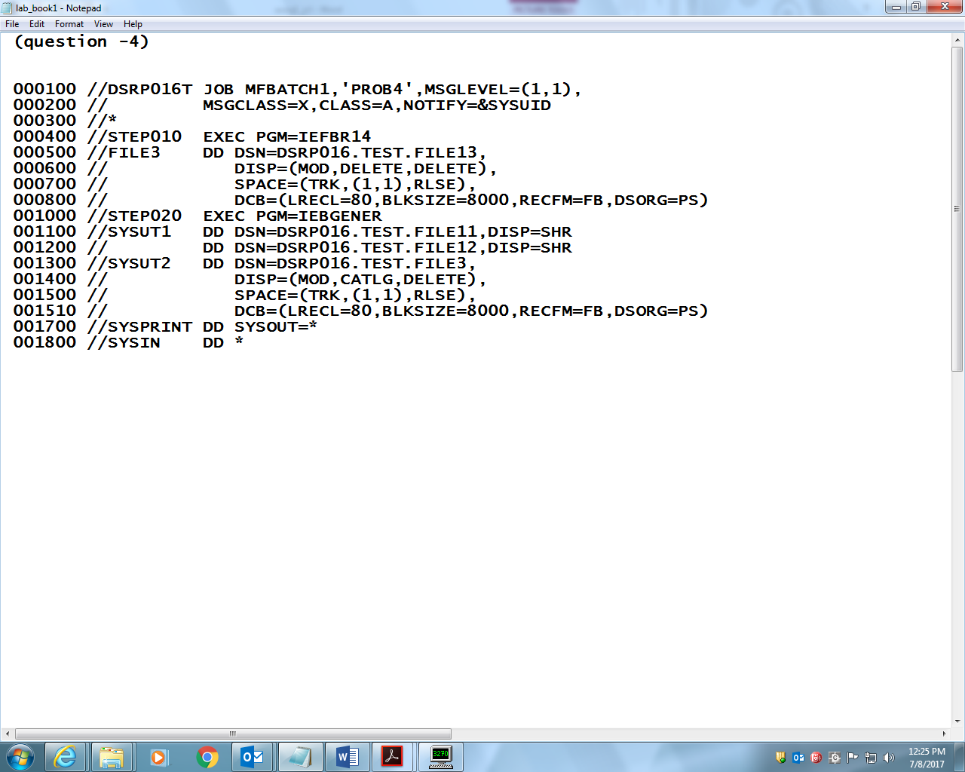

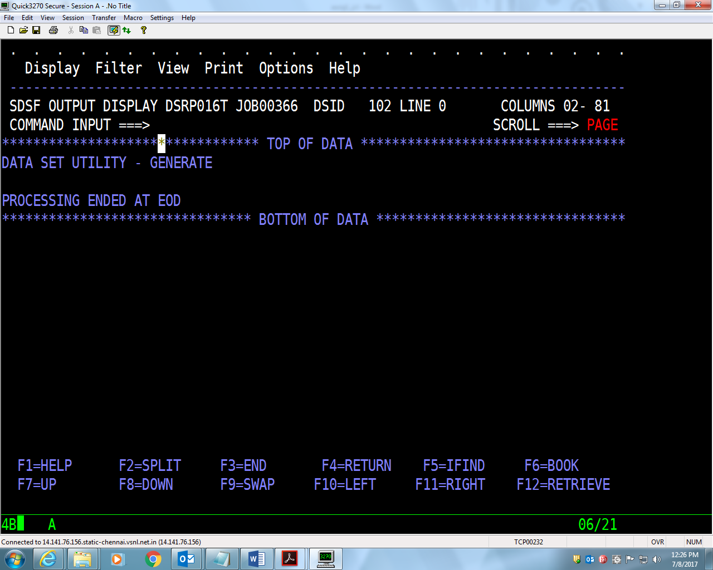

5. Write a JCL to sort the **EMPFILE** in descending or ascending order of **EMP-NO**.(ascending)

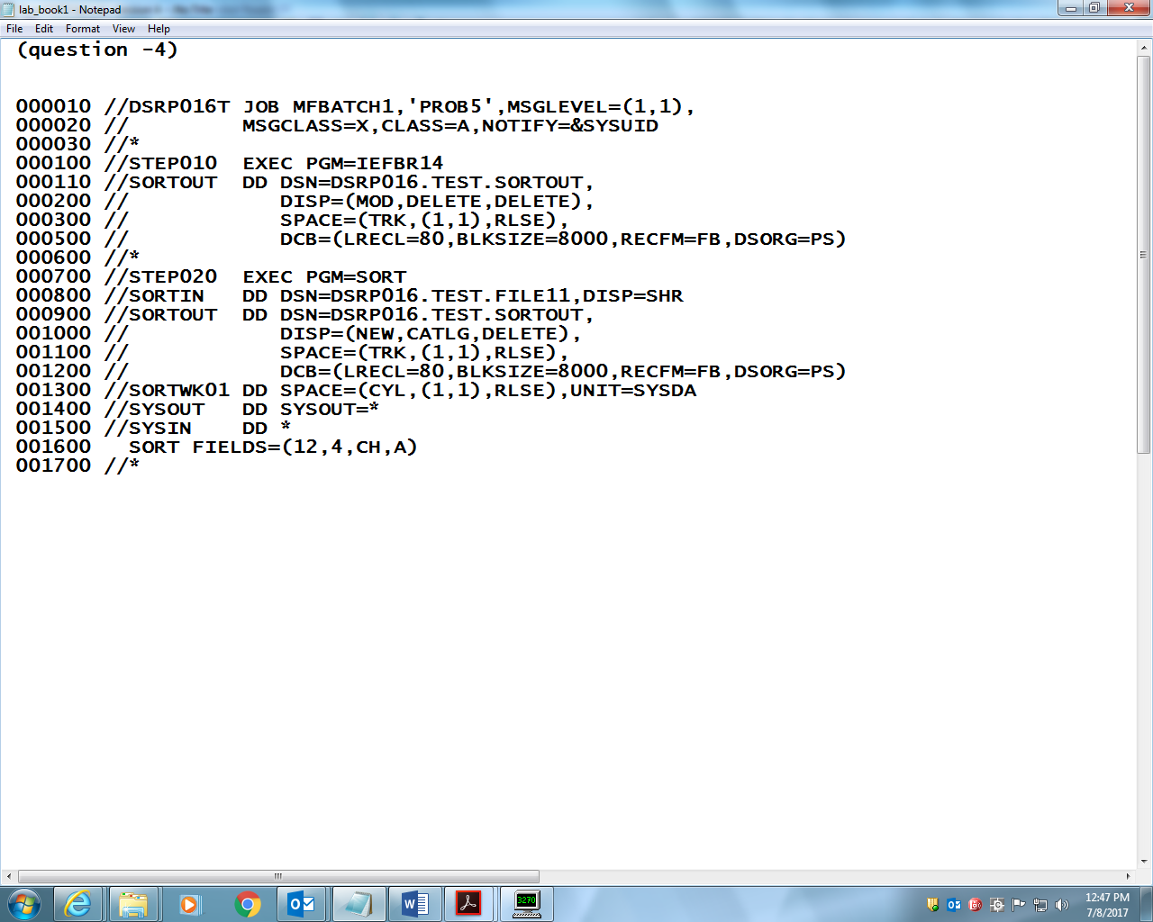

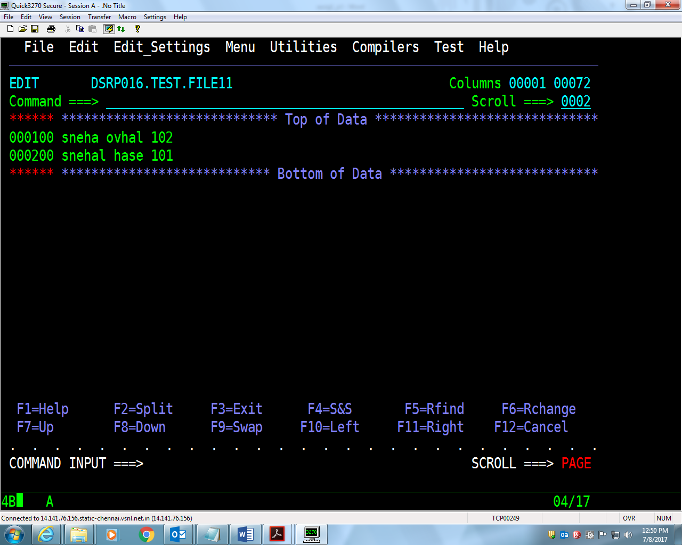

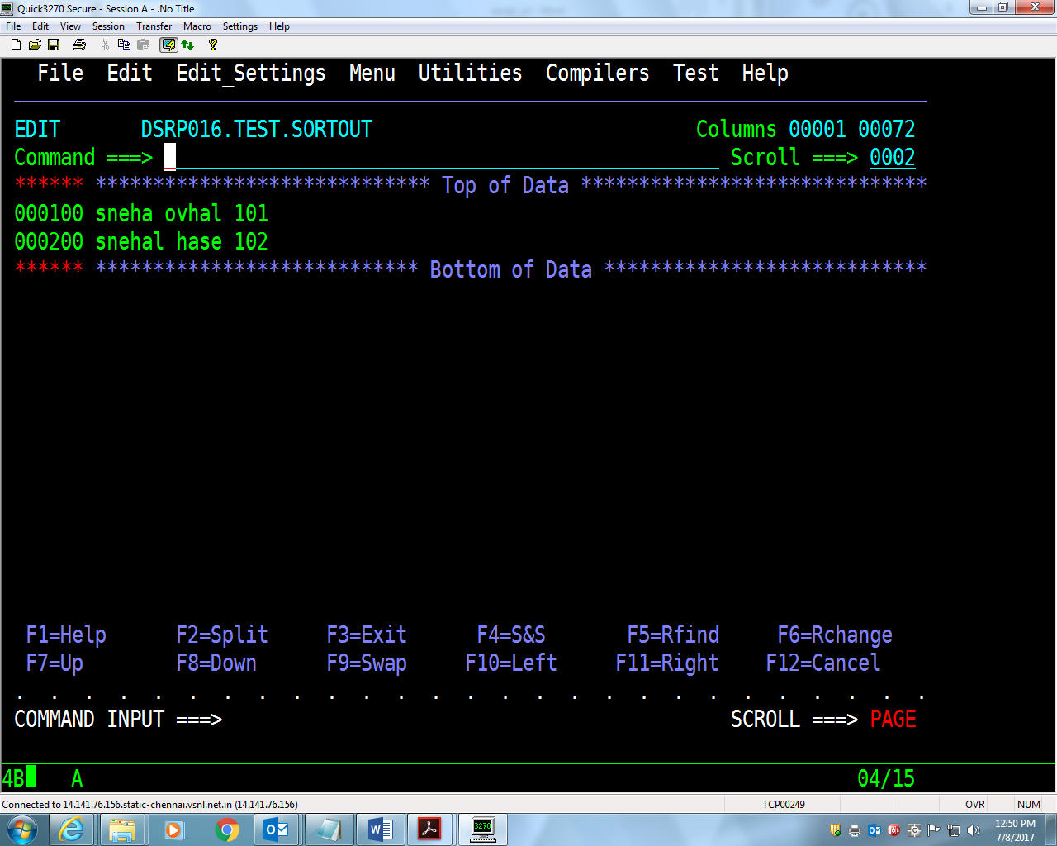

5. Write a JCL to sort the **EMPFILE** in descending or ascending order of **EMP-NO**.(descending)

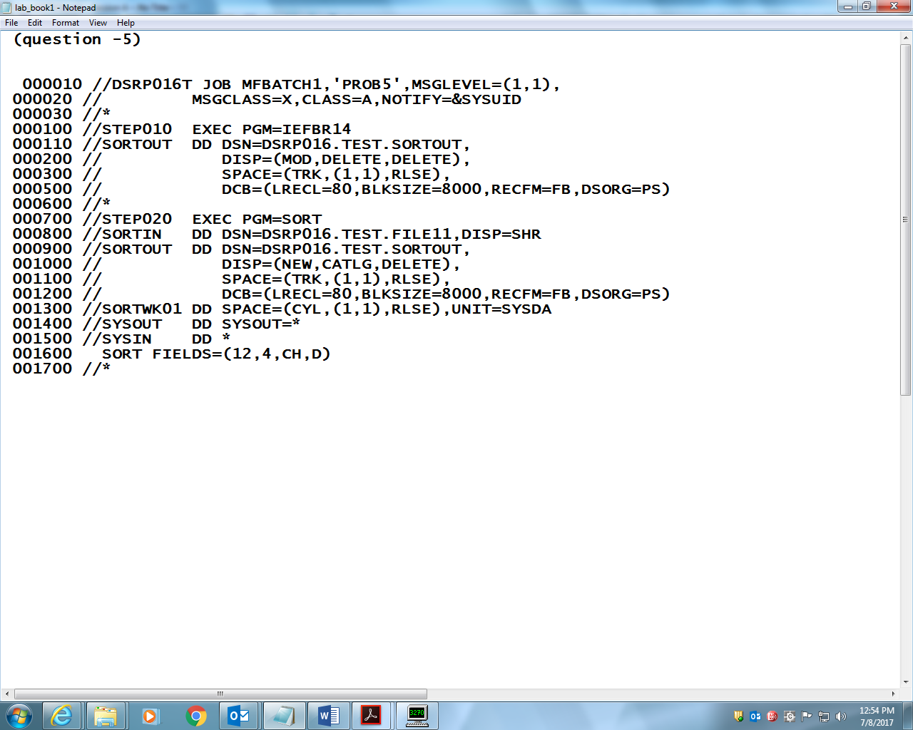

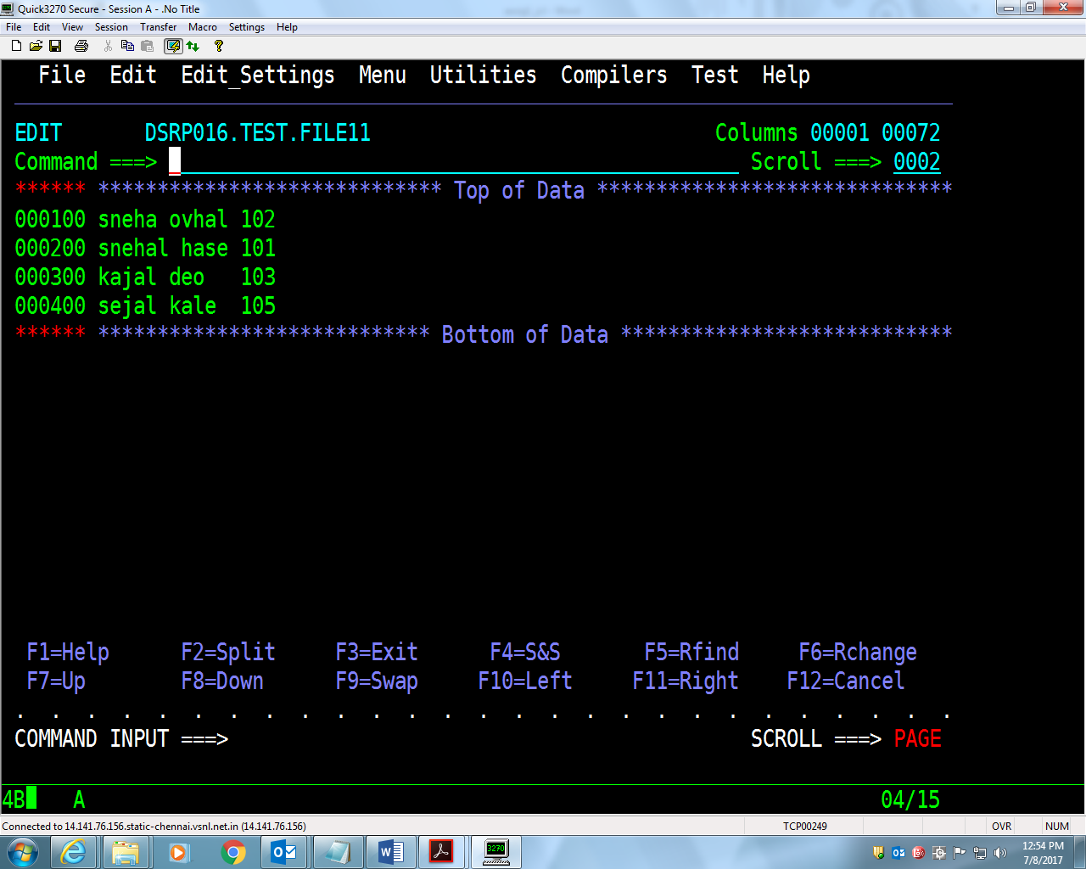

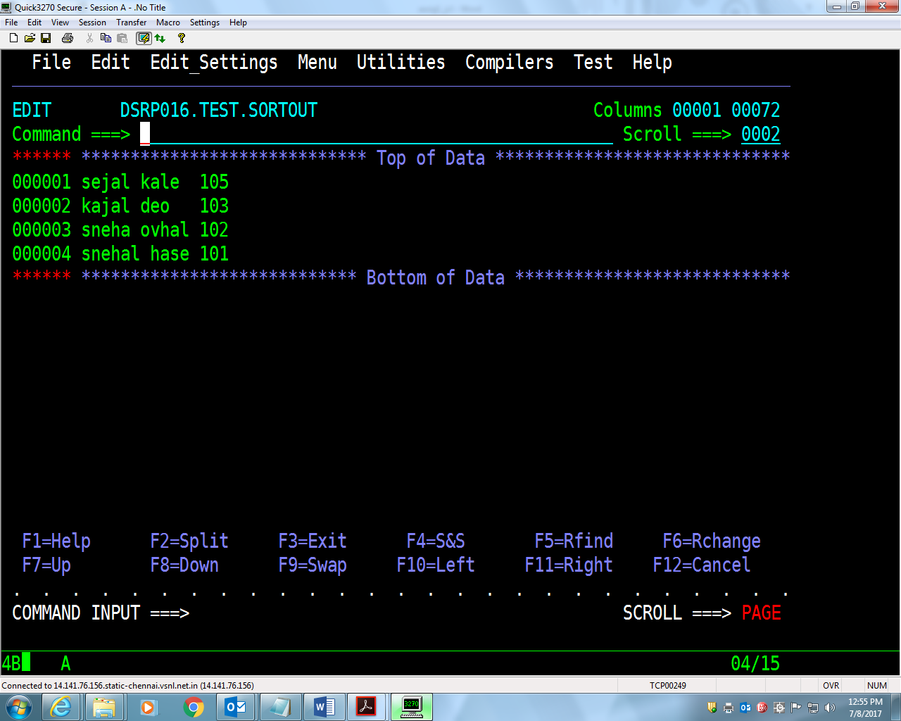

6. Try all the parameters for Sort, namely, INREC, OUTREC, SUM fields . ( OUTREC ))

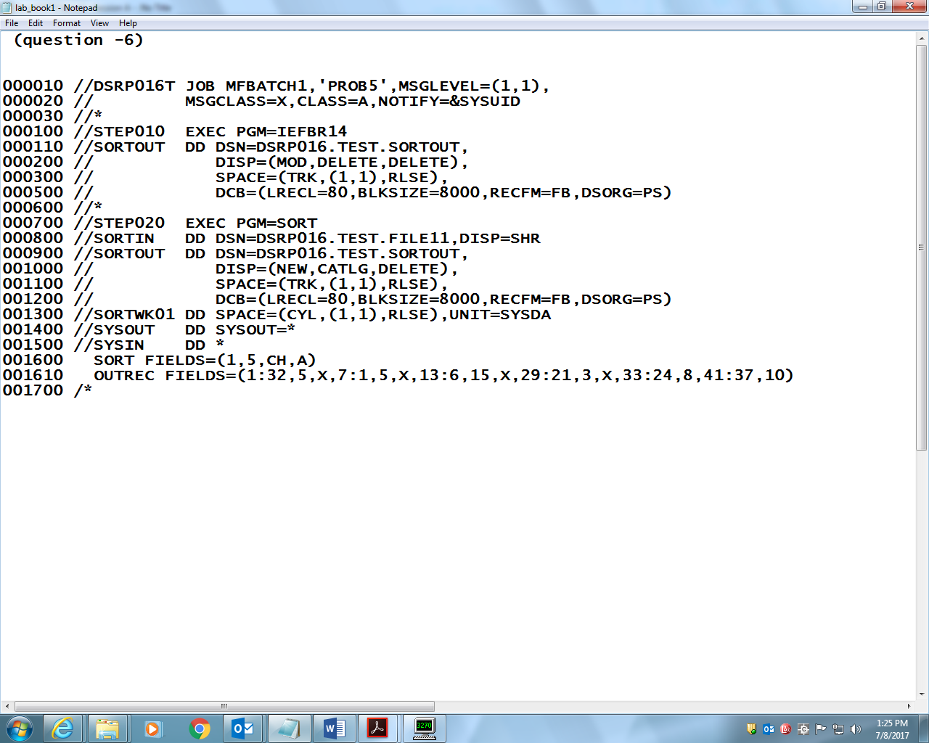

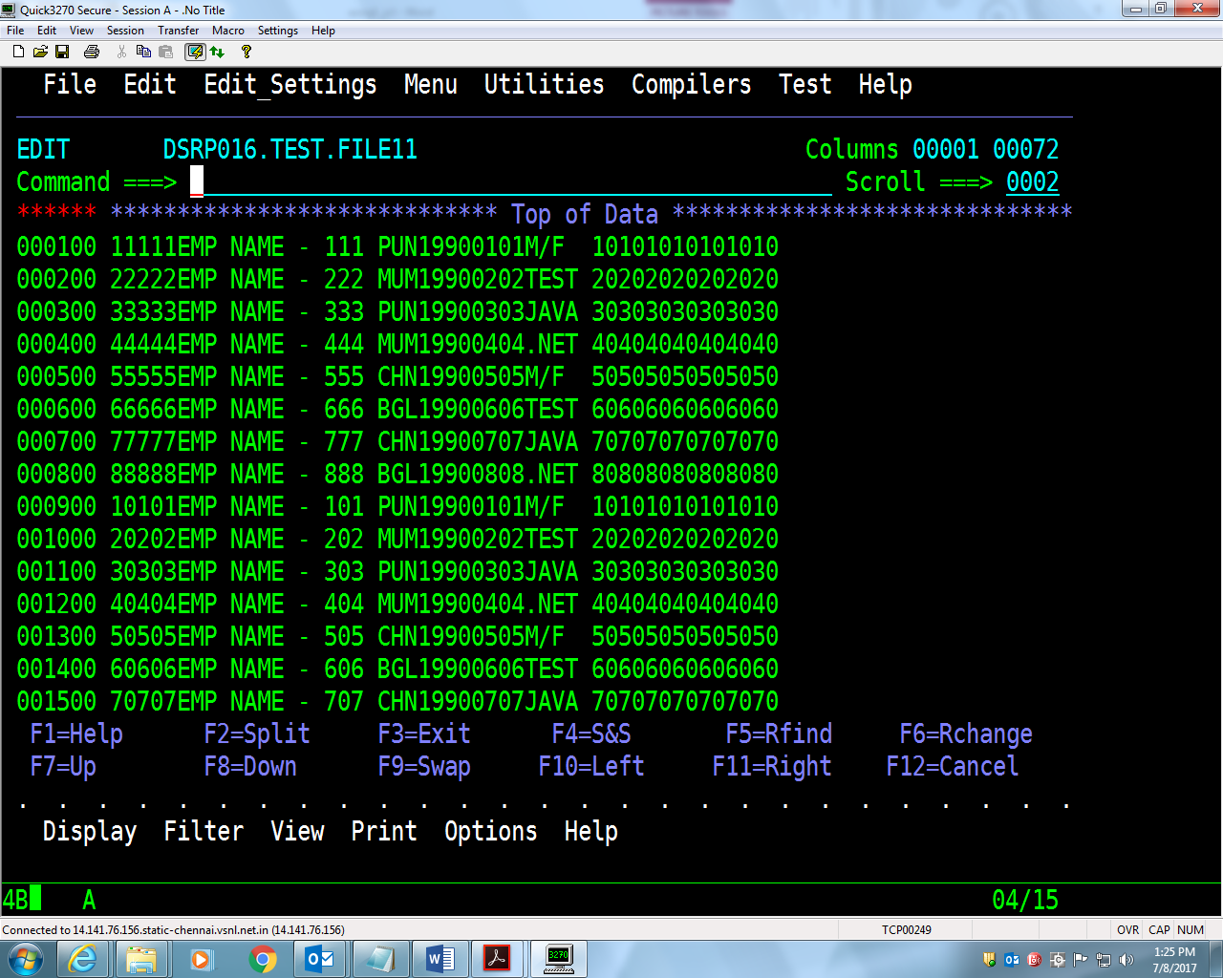

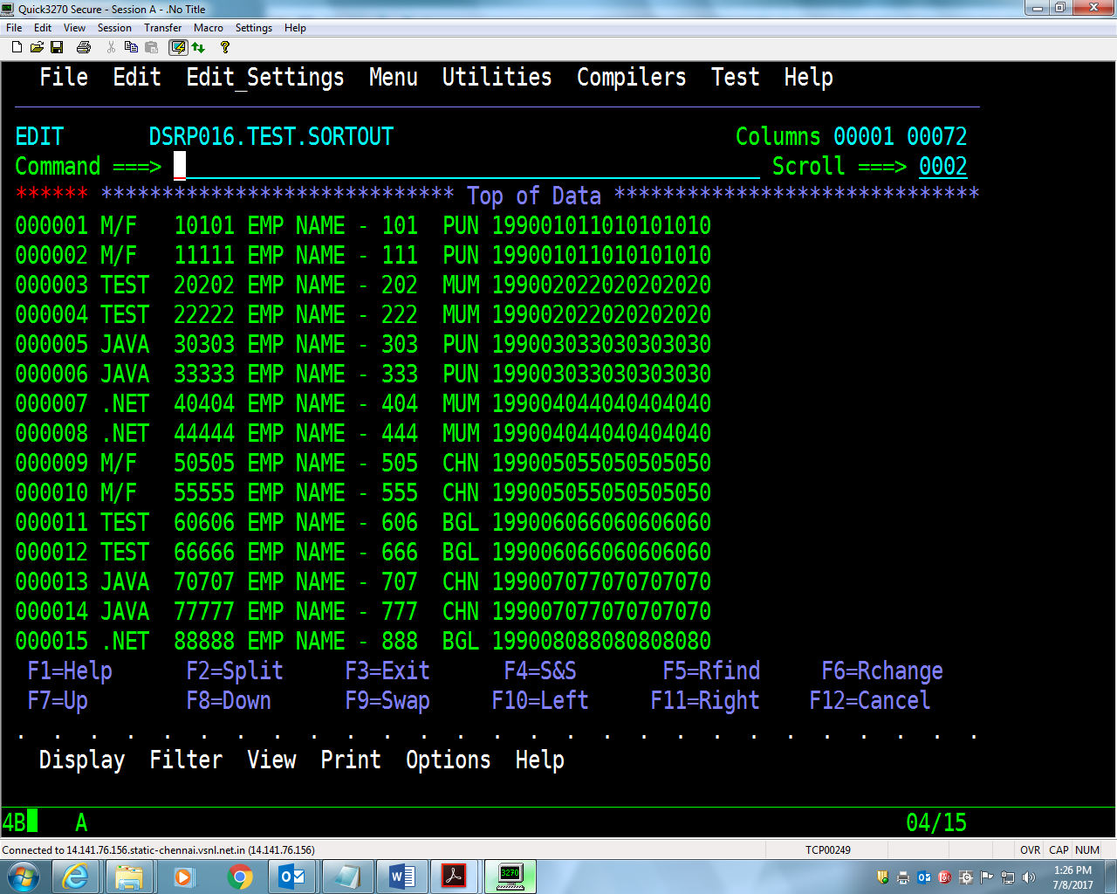

6. Try all the parameters for Sort, namely, INREC, OUTREC, SUM fields. (INREC)

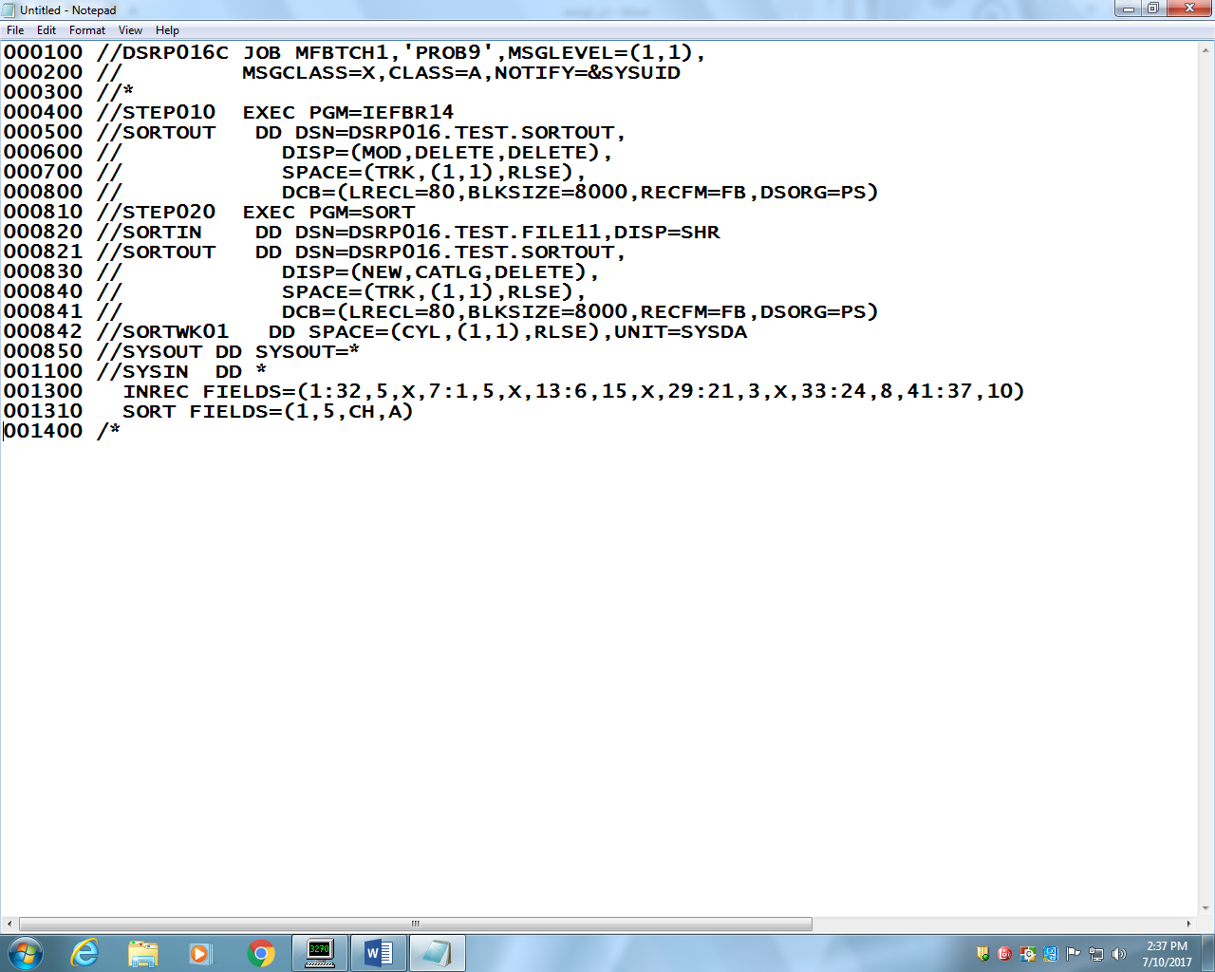

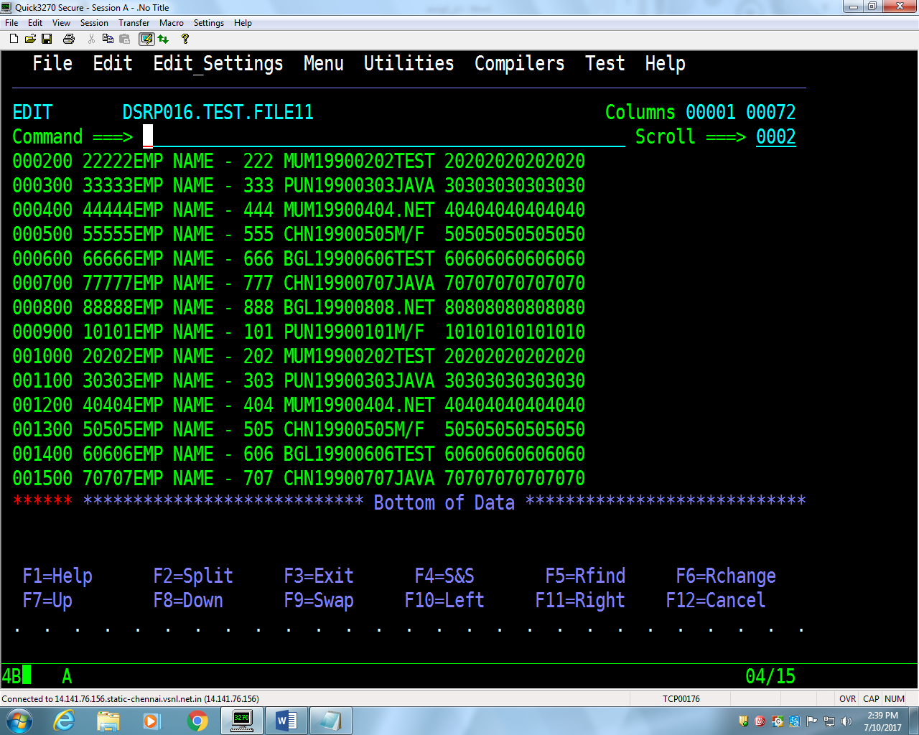

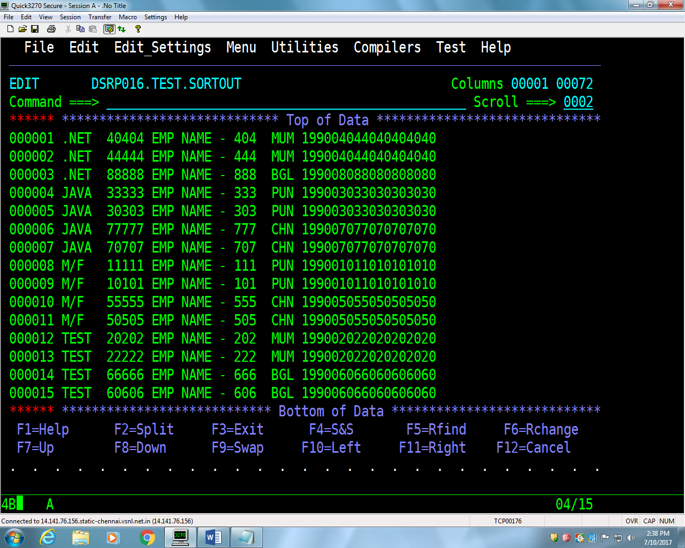

6. Try all the parameters for Sort, namely, INREC, OUTREC, SUM fields. (SUM FIELDS)

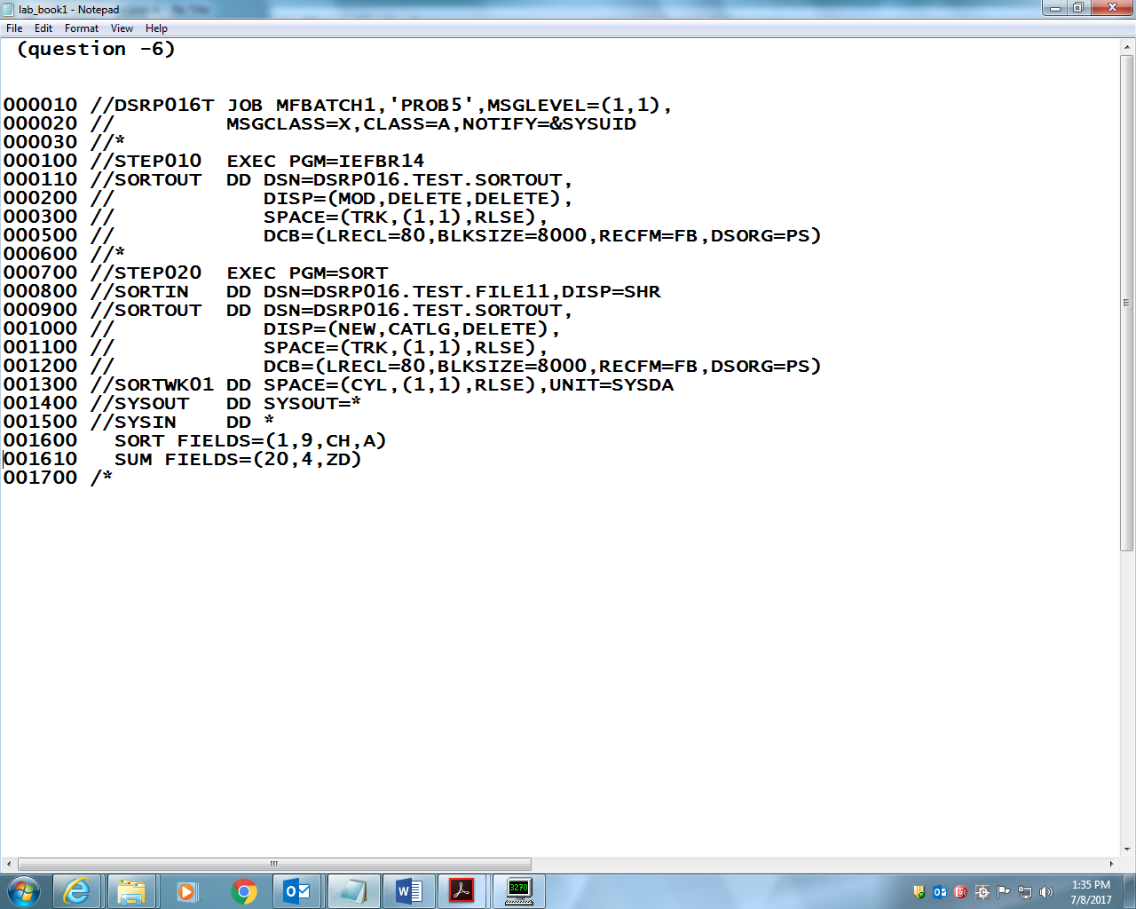

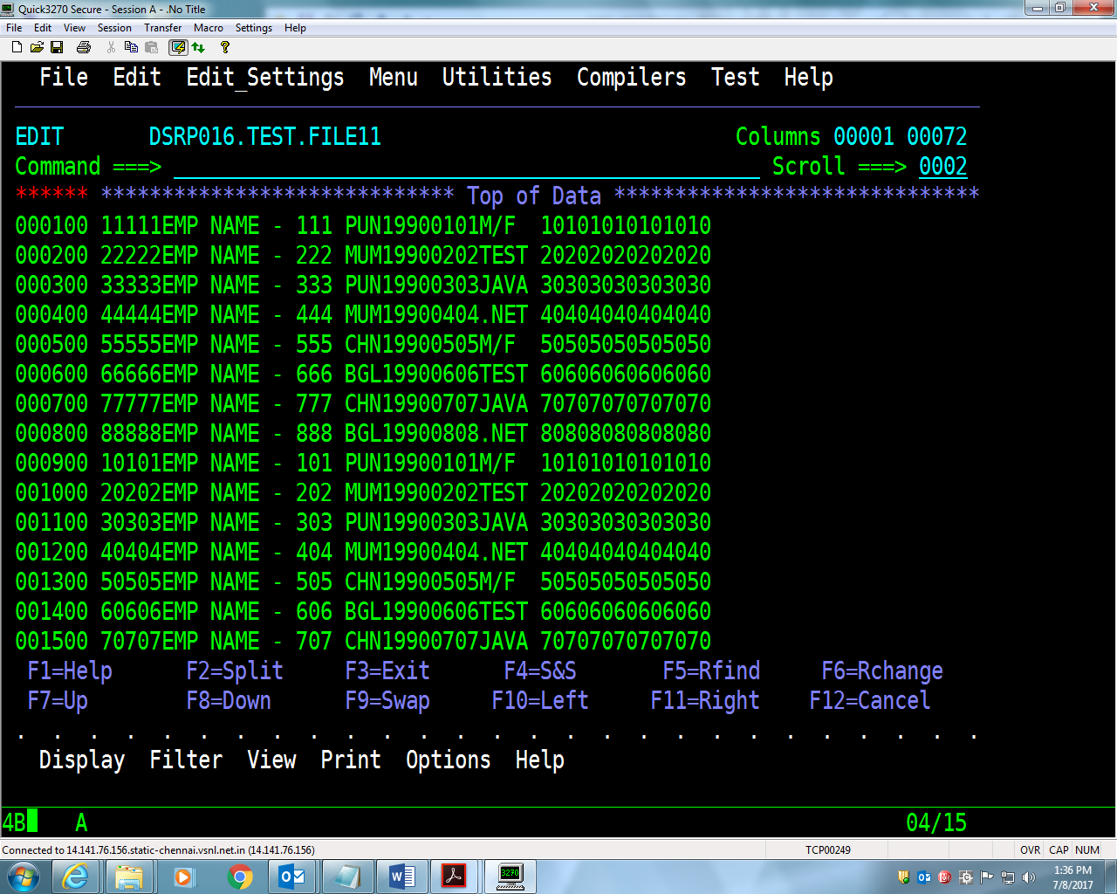

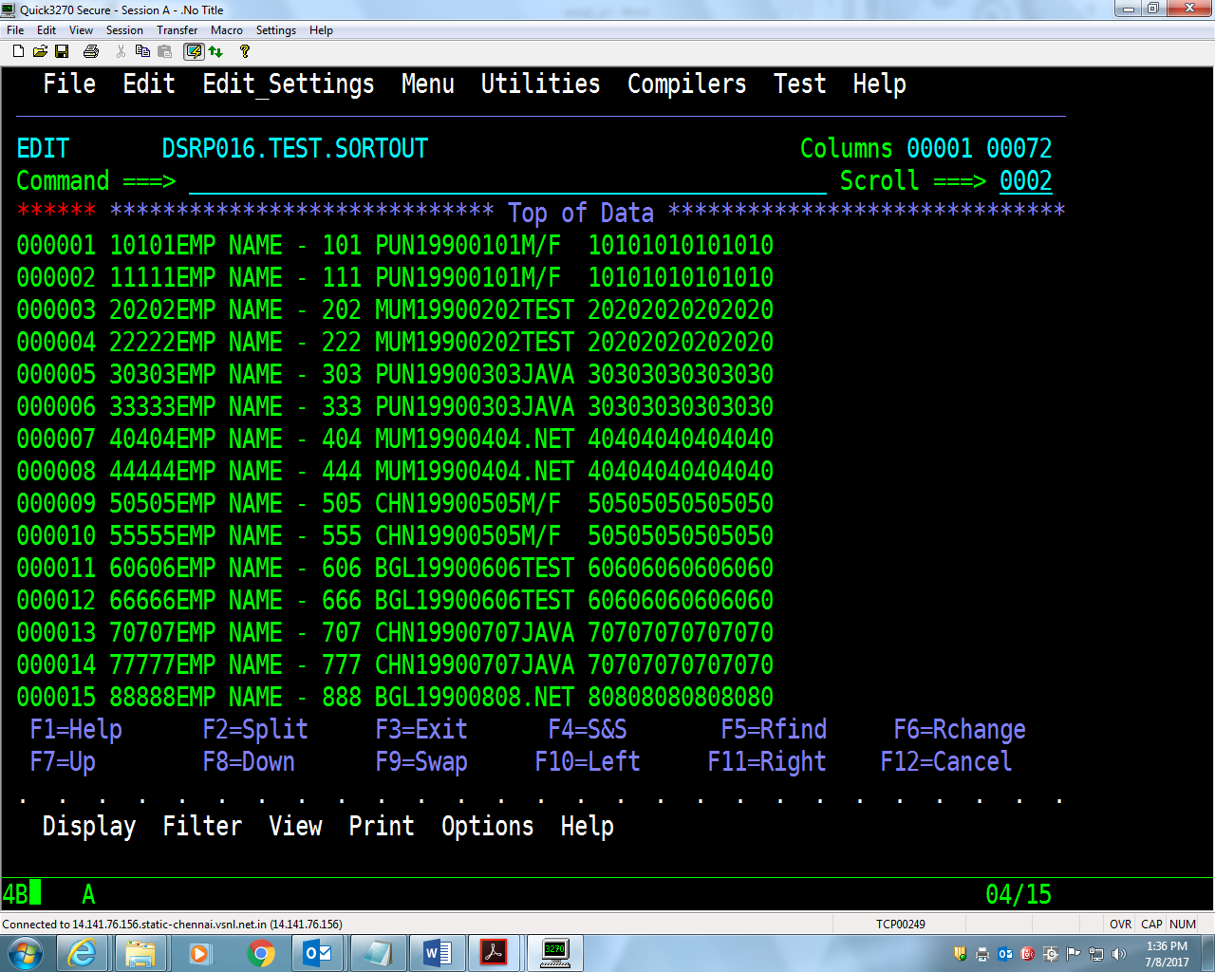

7. Create a PS Dept which includes (Deptno,DeptName,Loc) & list all the distinct

Departments in Ascending order from the Dept File(ASCENDING).

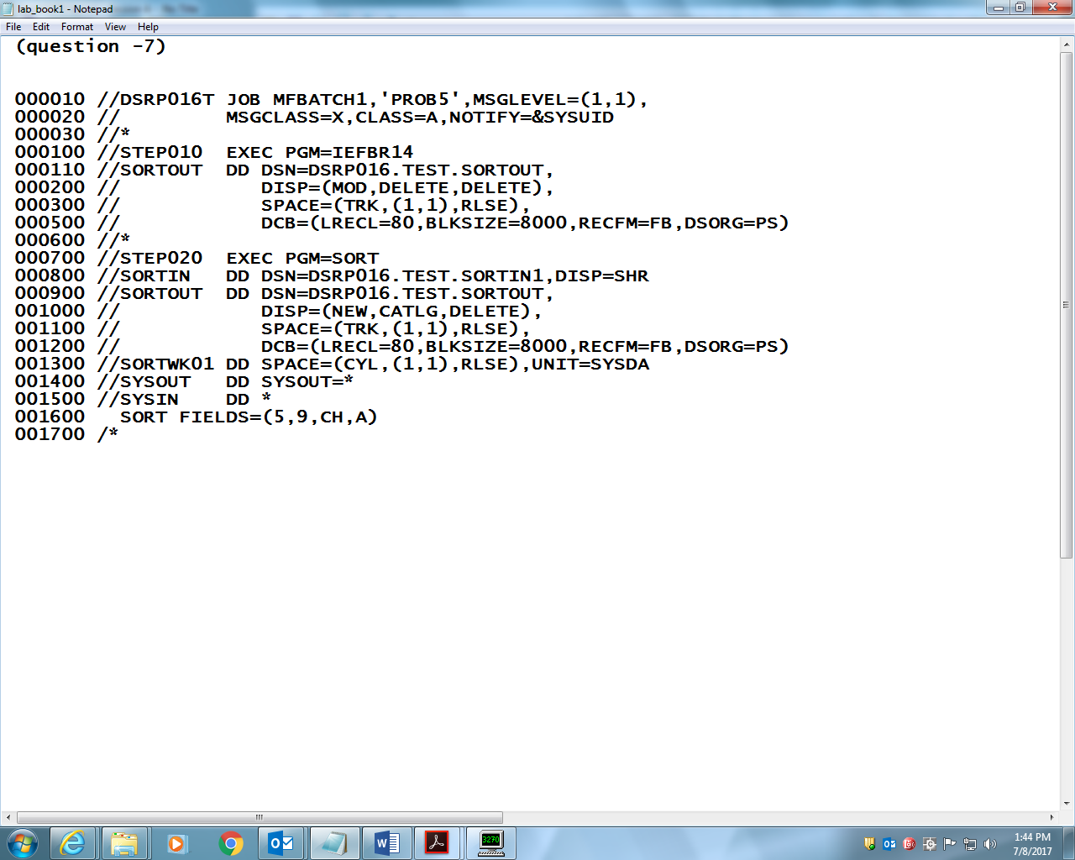

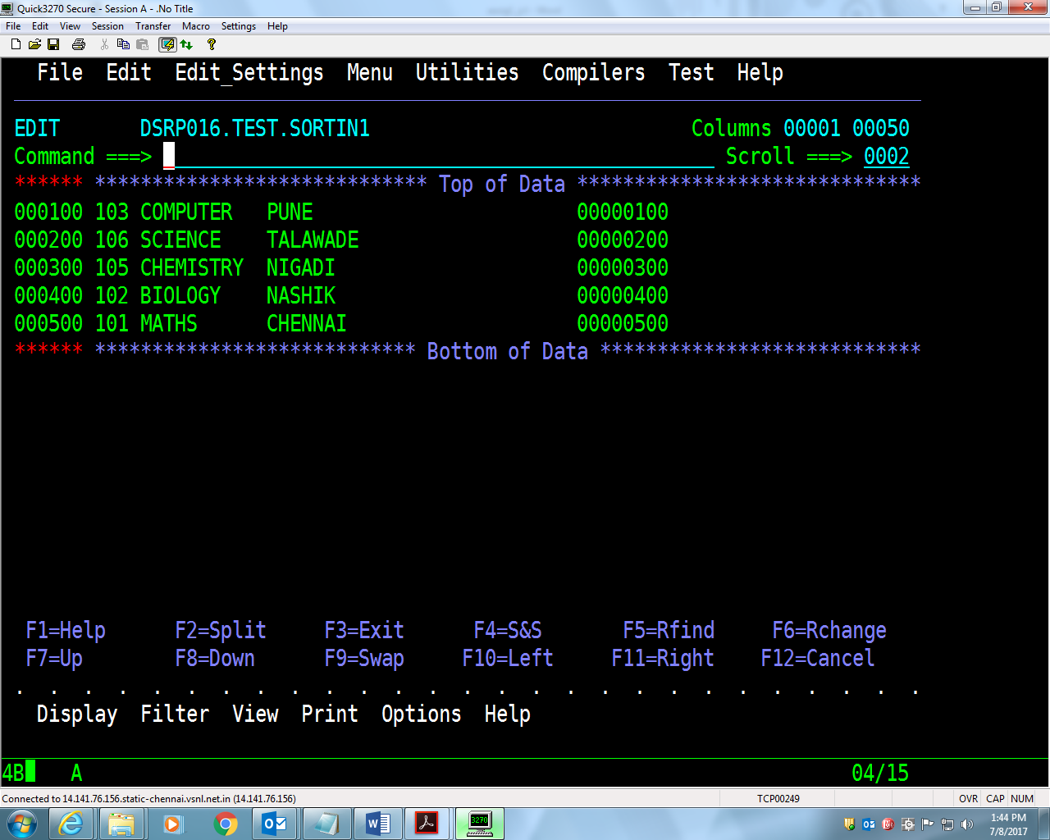

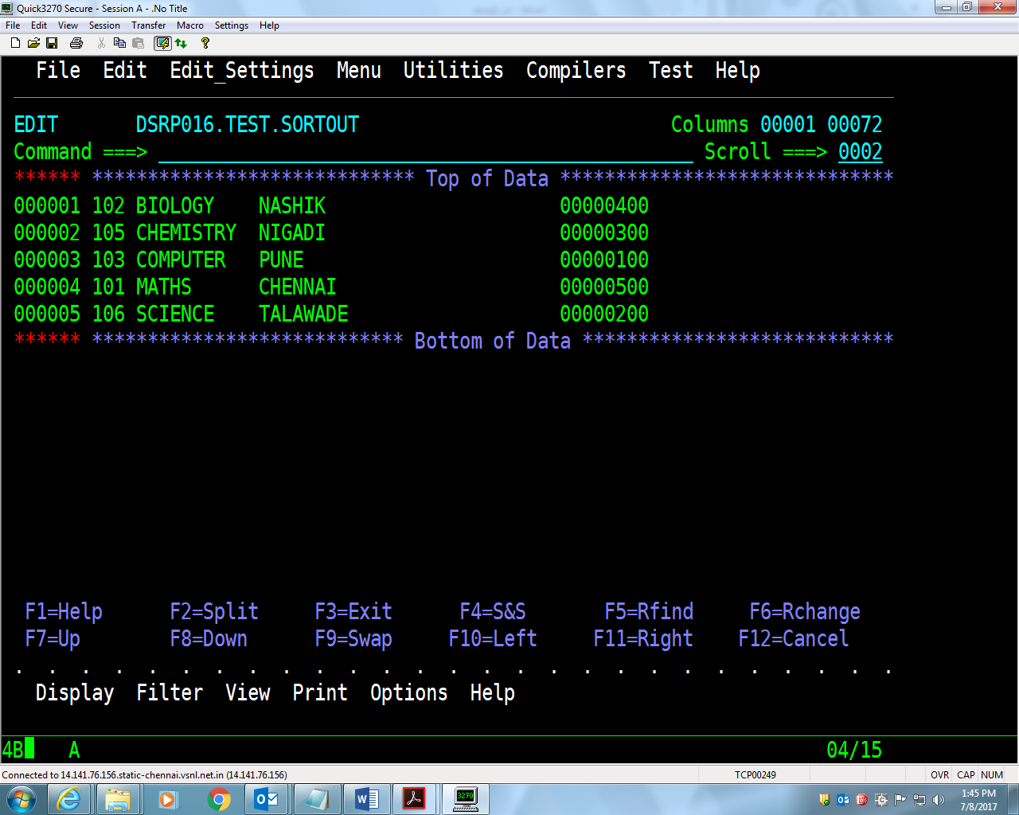

8. Write a cataloged procedure for invoking either **IEFBR14** or **IEBGENER** or

**SORT** utility.

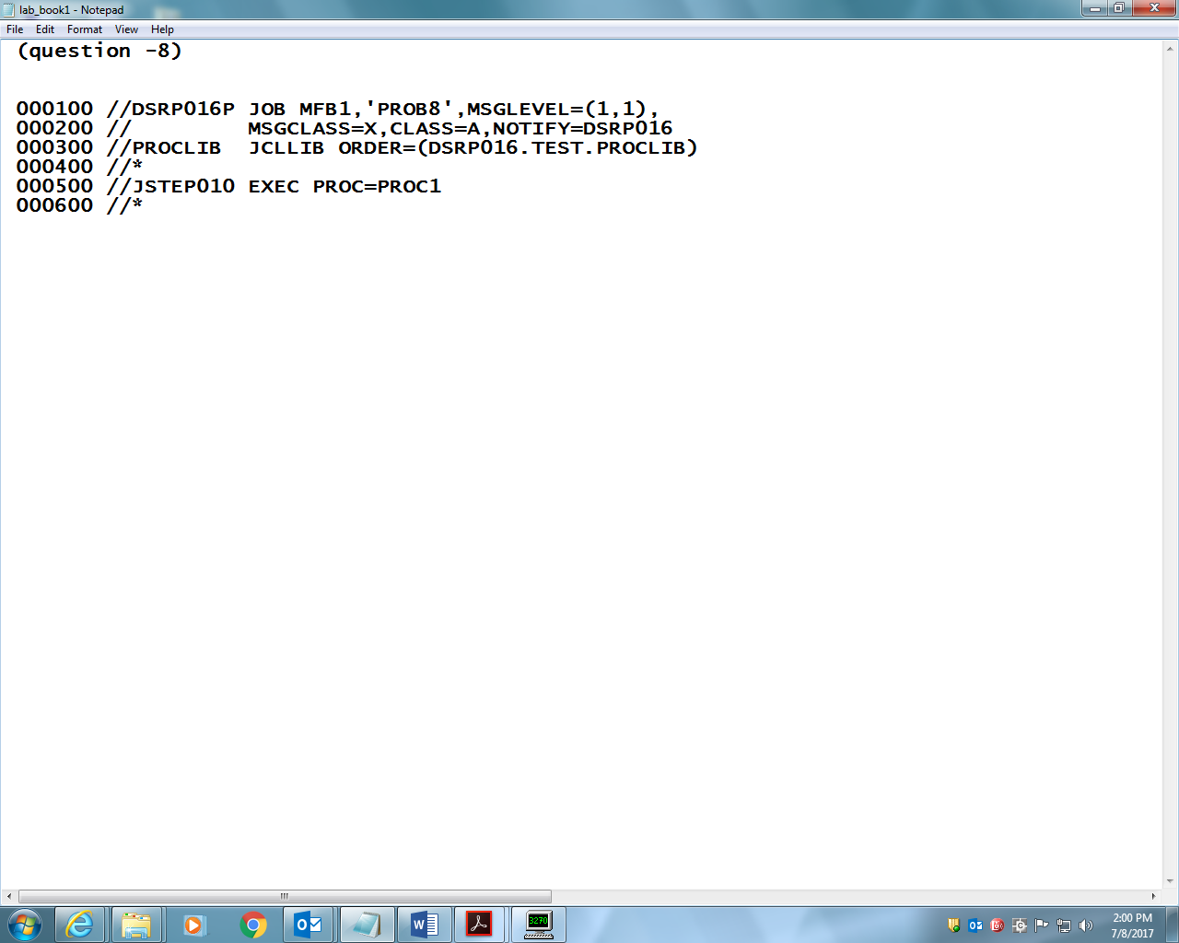

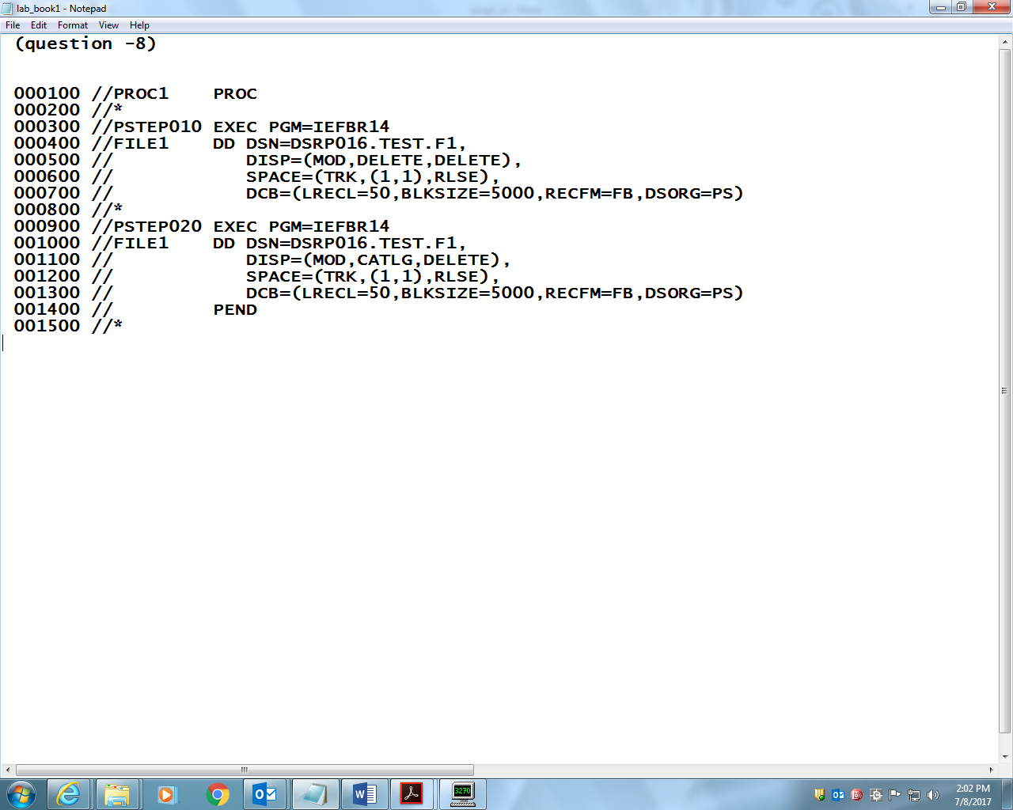

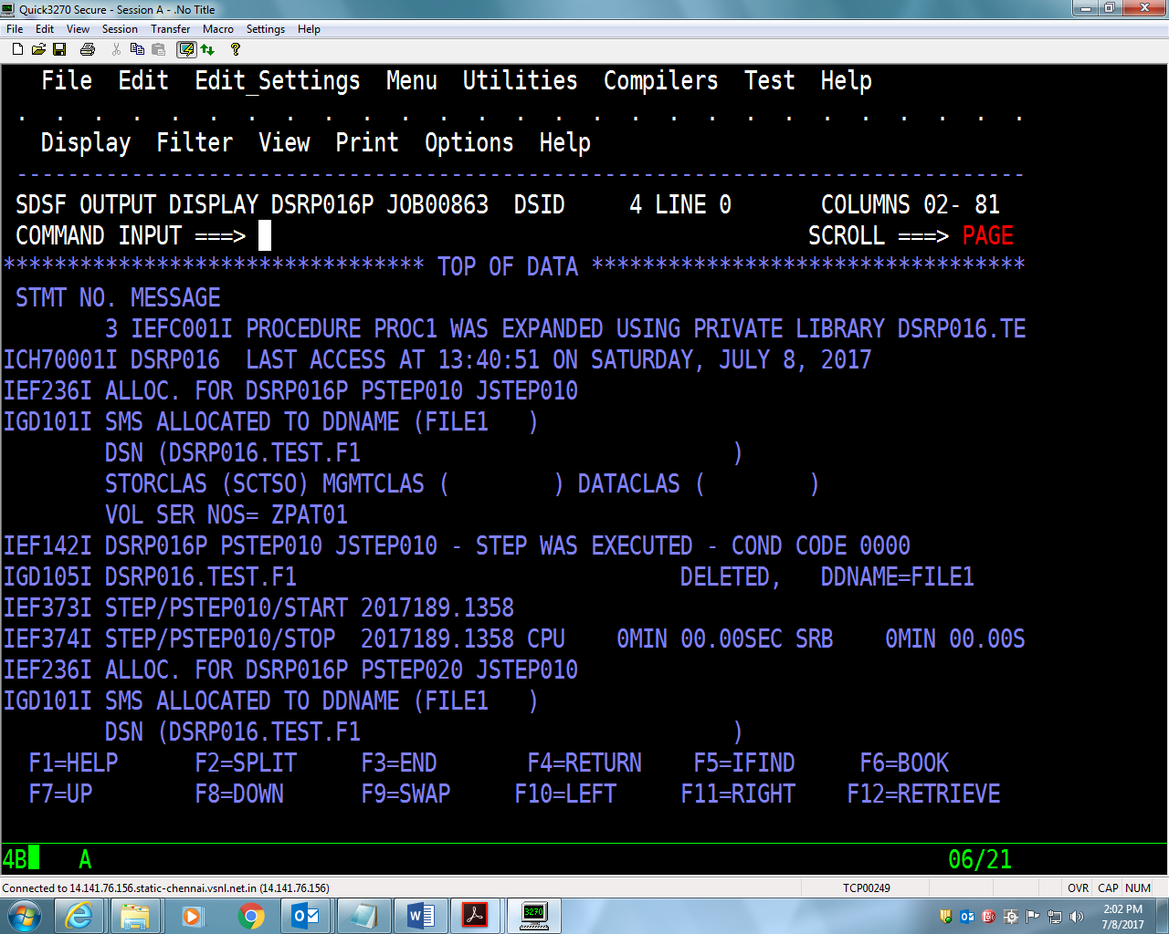

9. Write an **instream** procedure for the assignment 7.

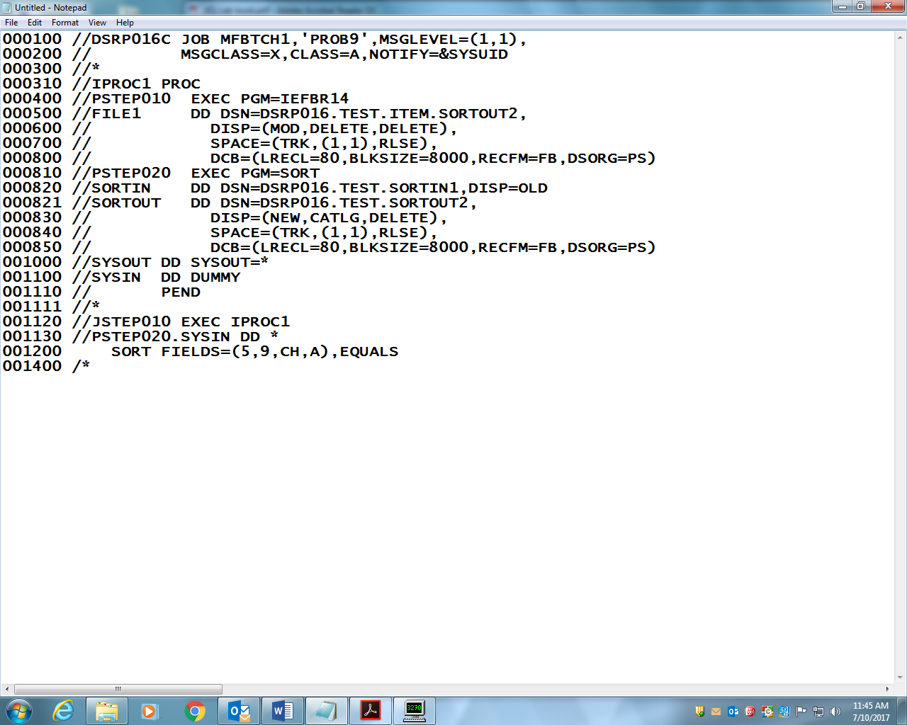

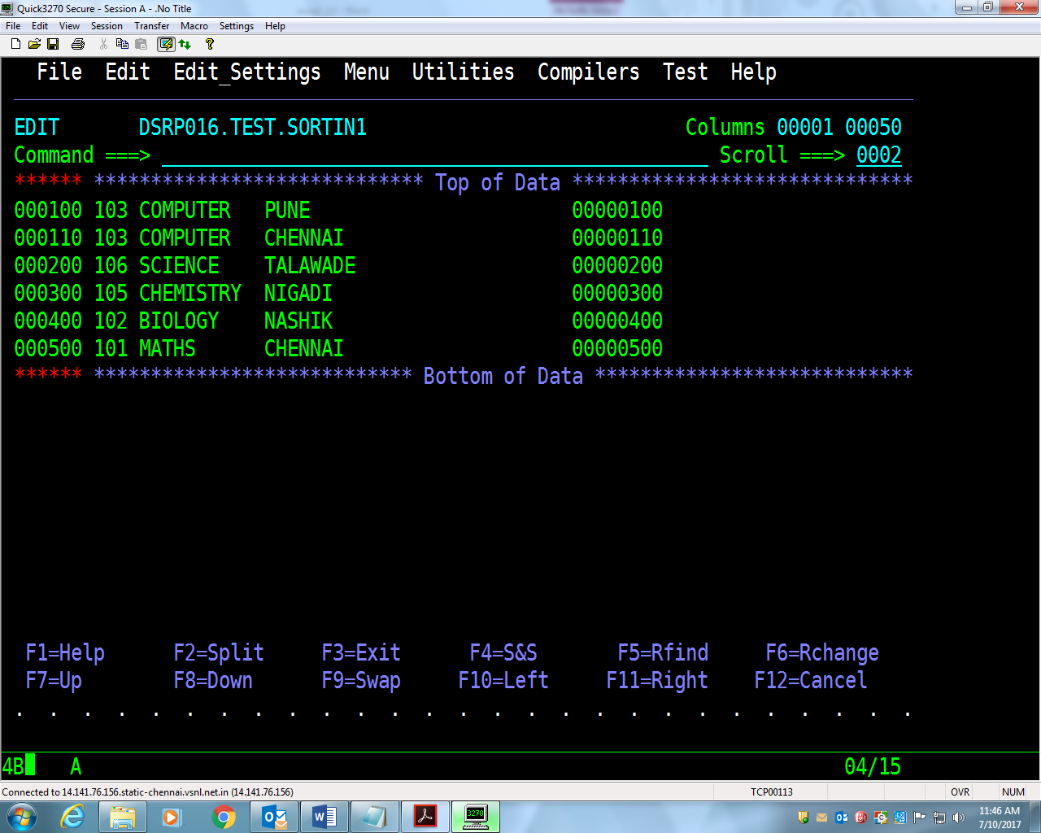

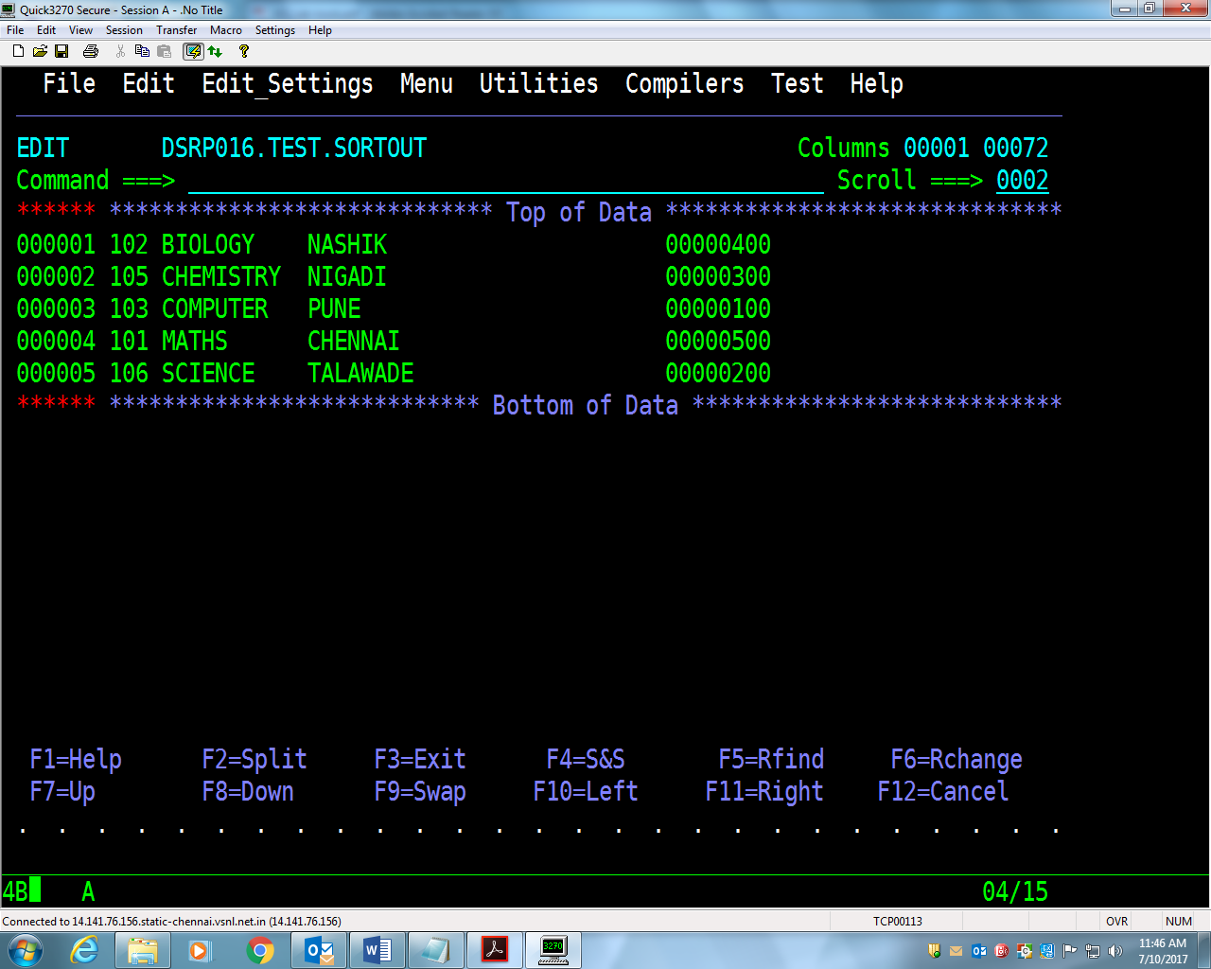

10. Using the ITEM-FILE as Sample Input, write the solution for following

assignments

**Assignment-1:** Write a JCL to create an output file having unique records (with

respect to Item Code column) using the **SORT** utility.

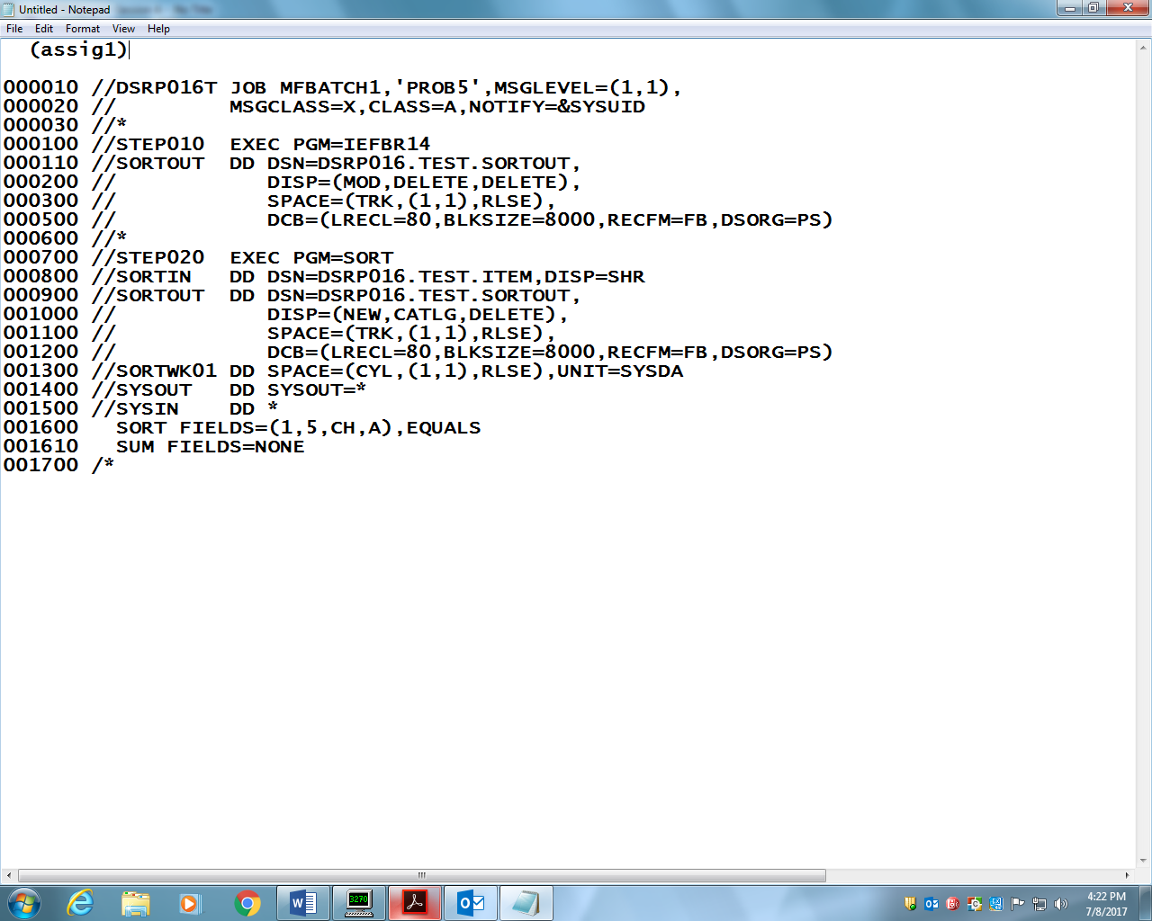

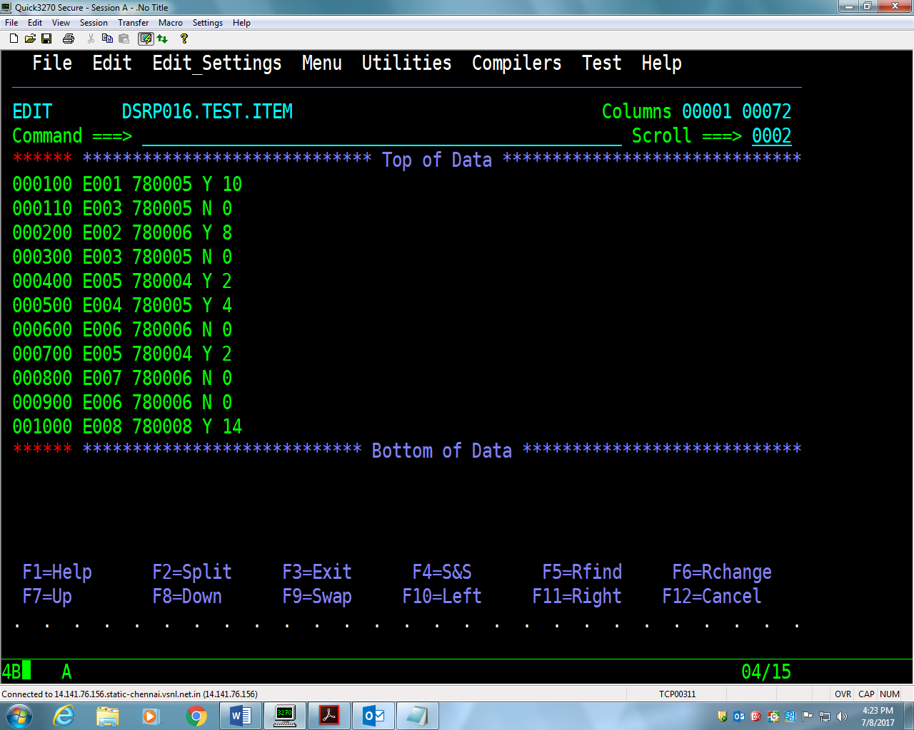

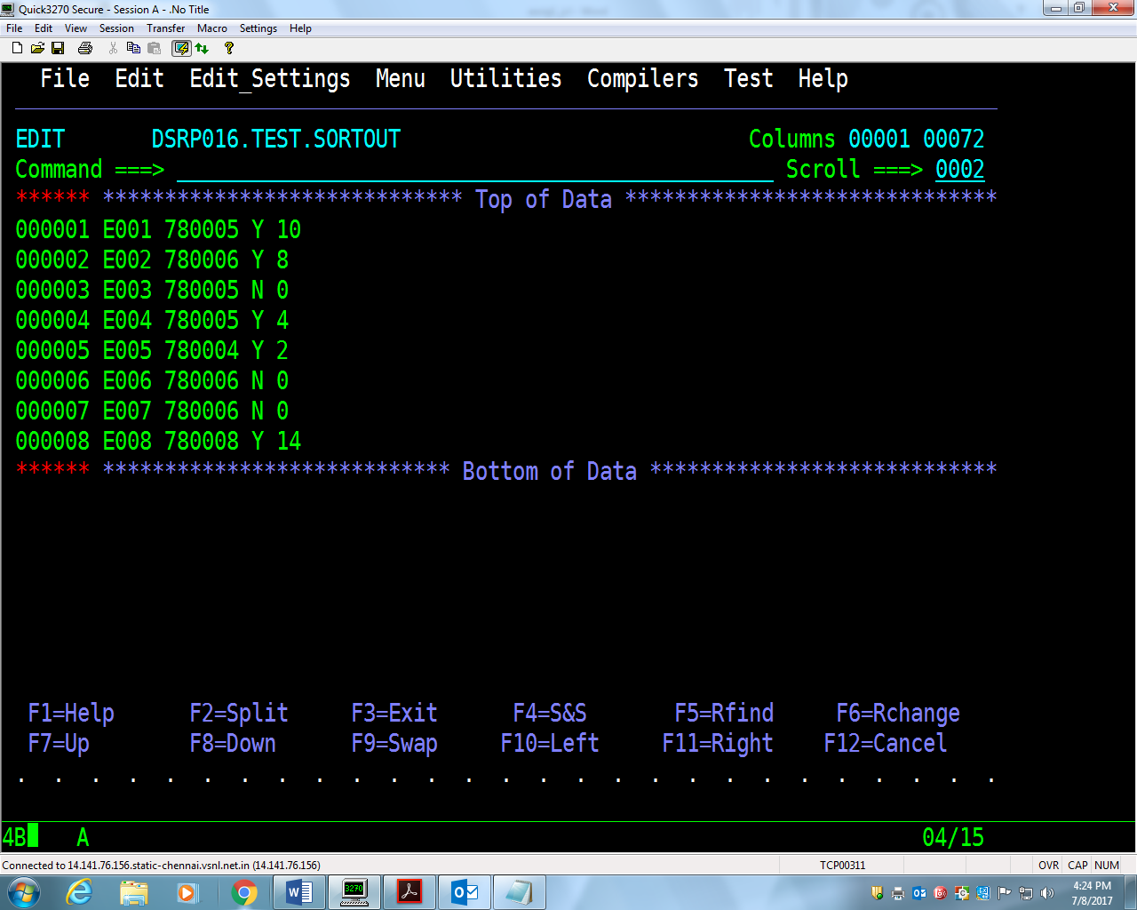

**Assignment-2:** Write a JCL to extract records having Item-code ‘E003’ in new file

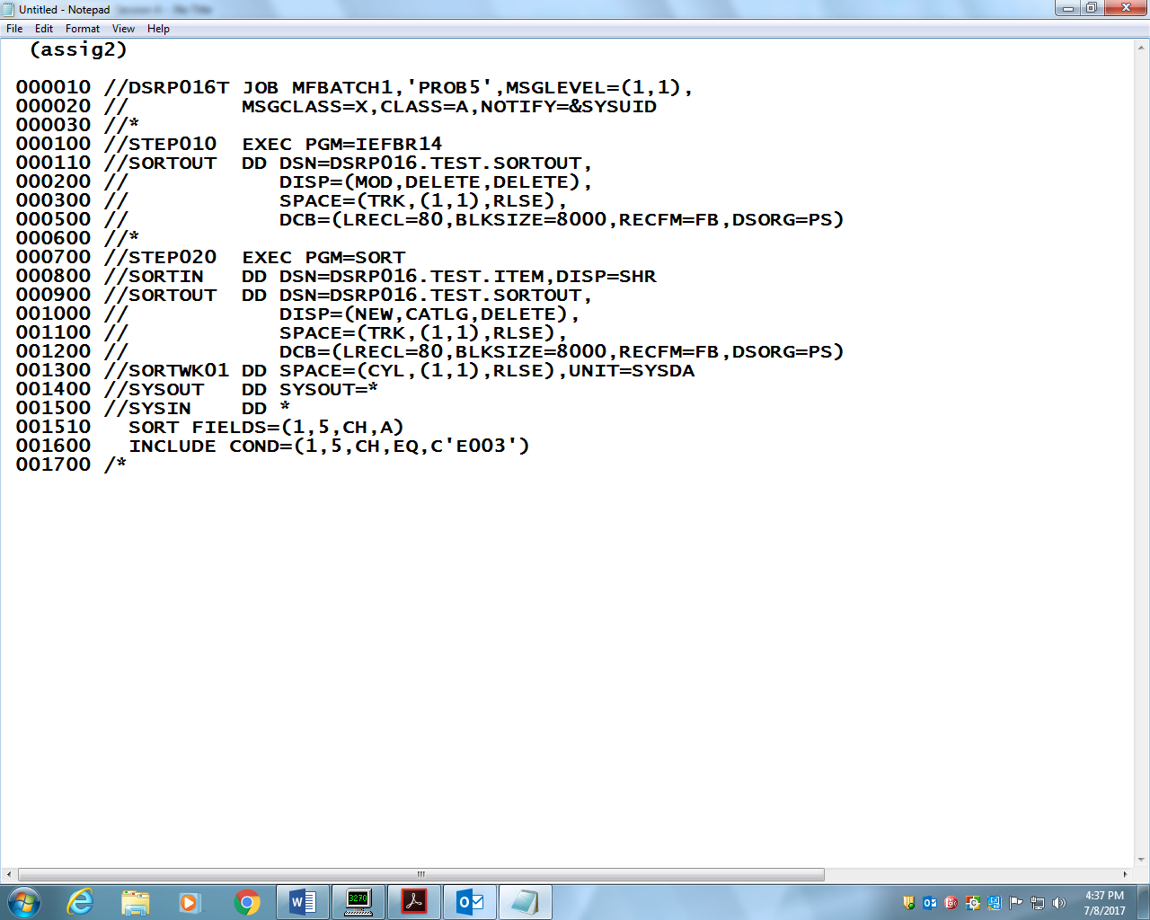

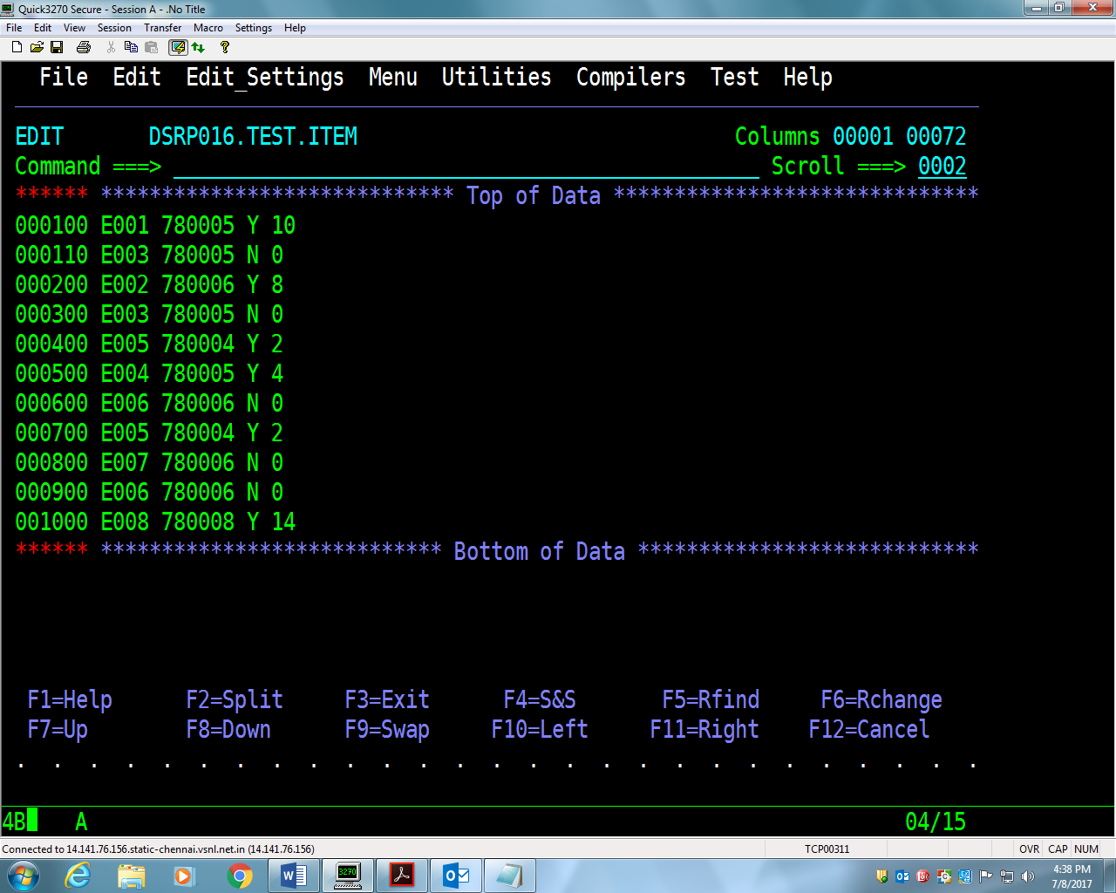

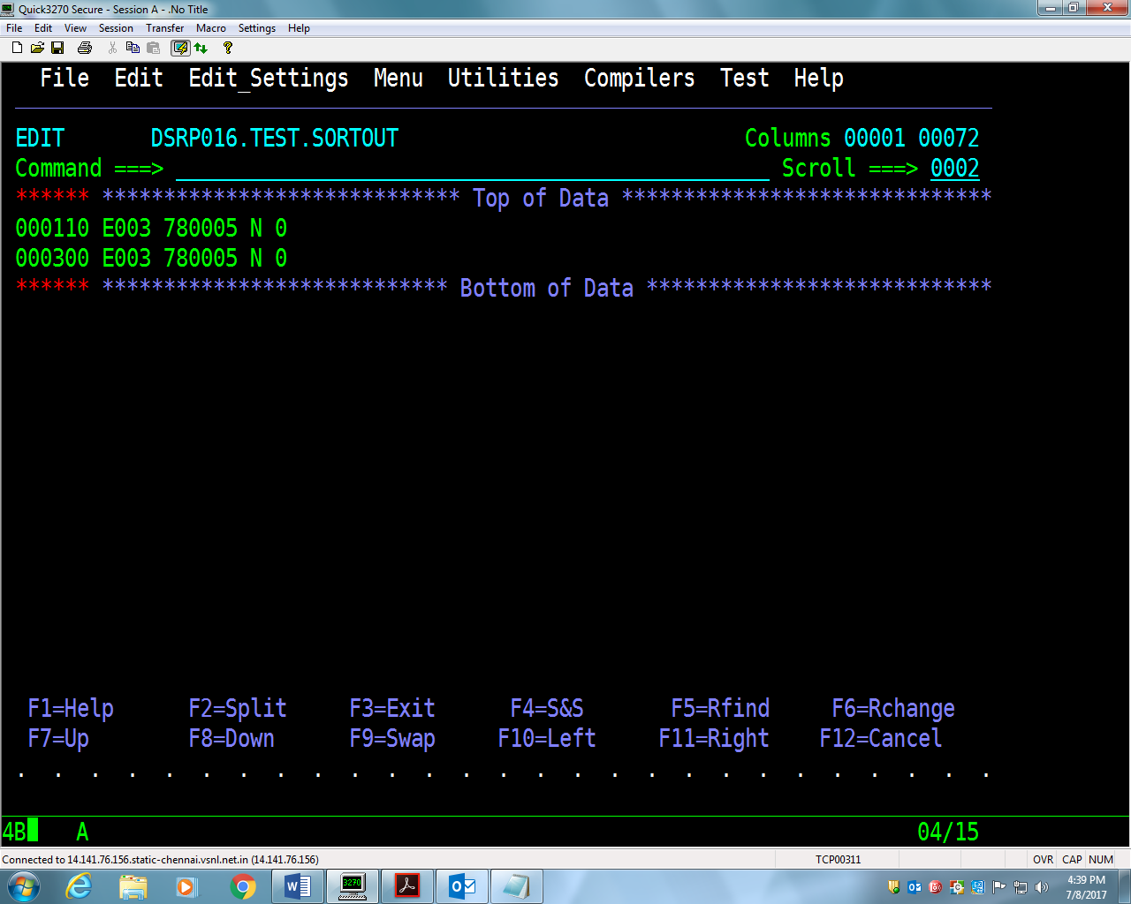

**Assignment-3:** Write a JCL to create a file having only two columns (using

OUTREC) using SORT utility.

[Create Vendor-Item-File having only two fields say Item-Code and Vendor].

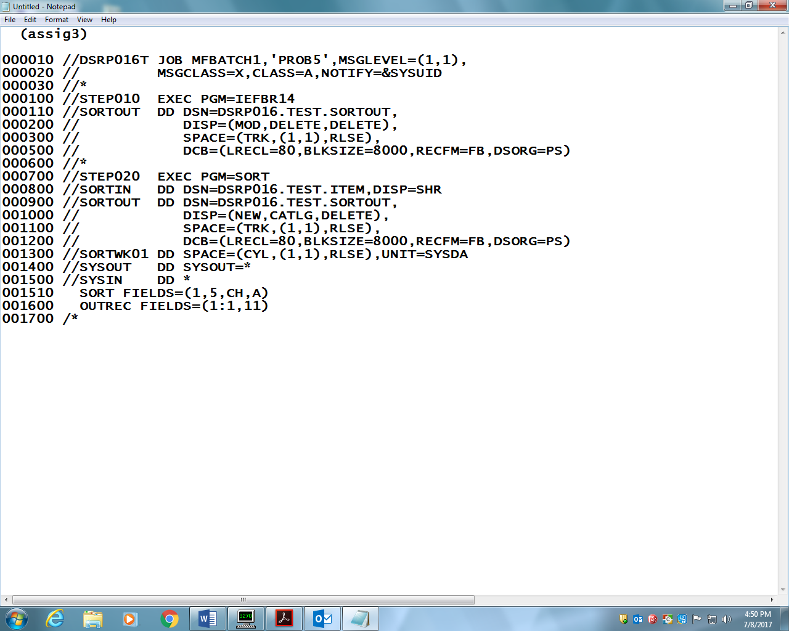

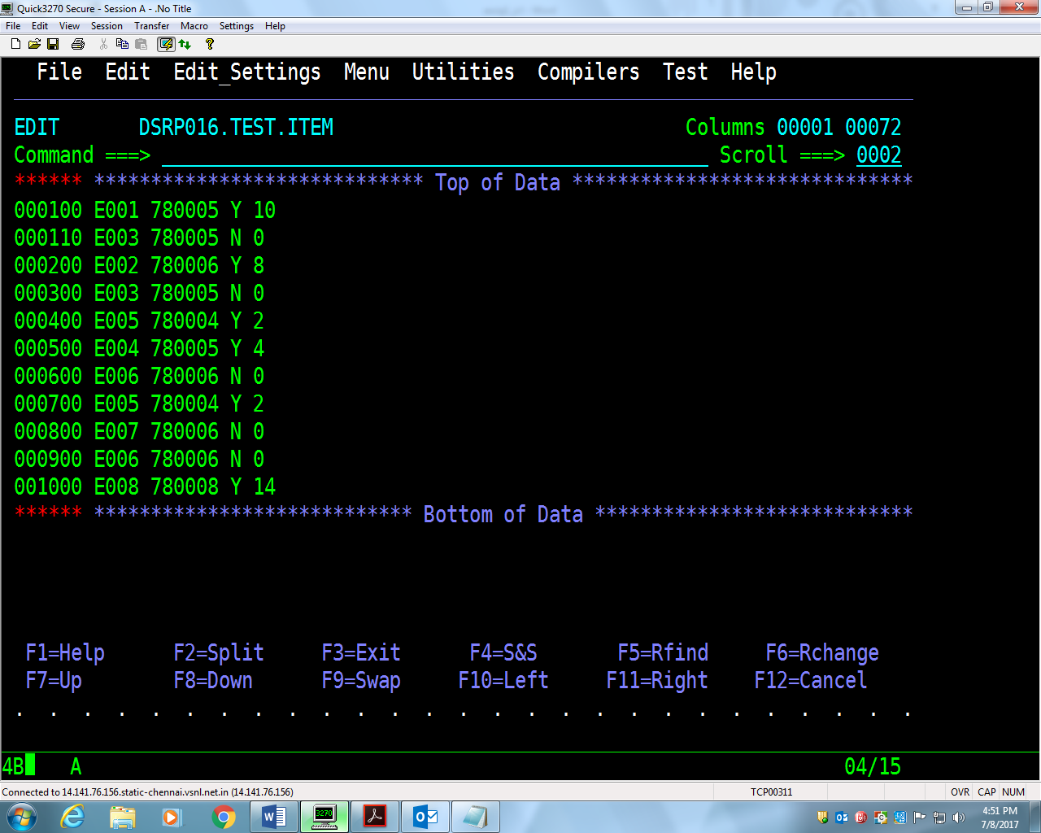

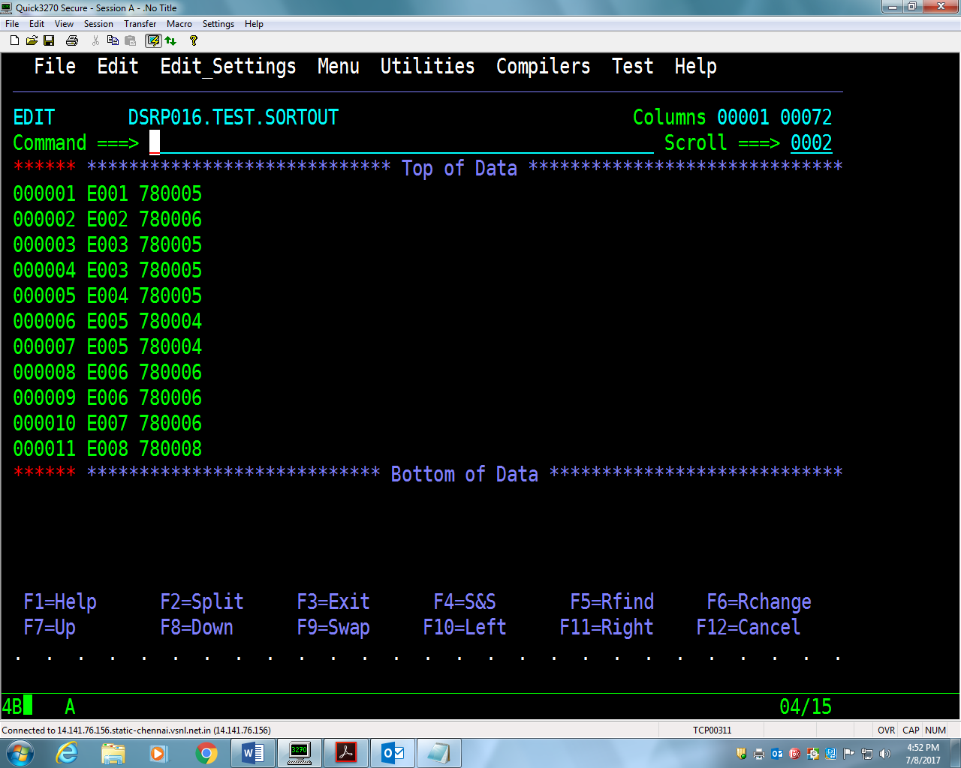

**Assignment-4:** Taking above **Item-File** as input, write a JCL to create another file

(ITEM-FILE-SEQ) having same data and sequence-number as additional column

using **SORT** utility.

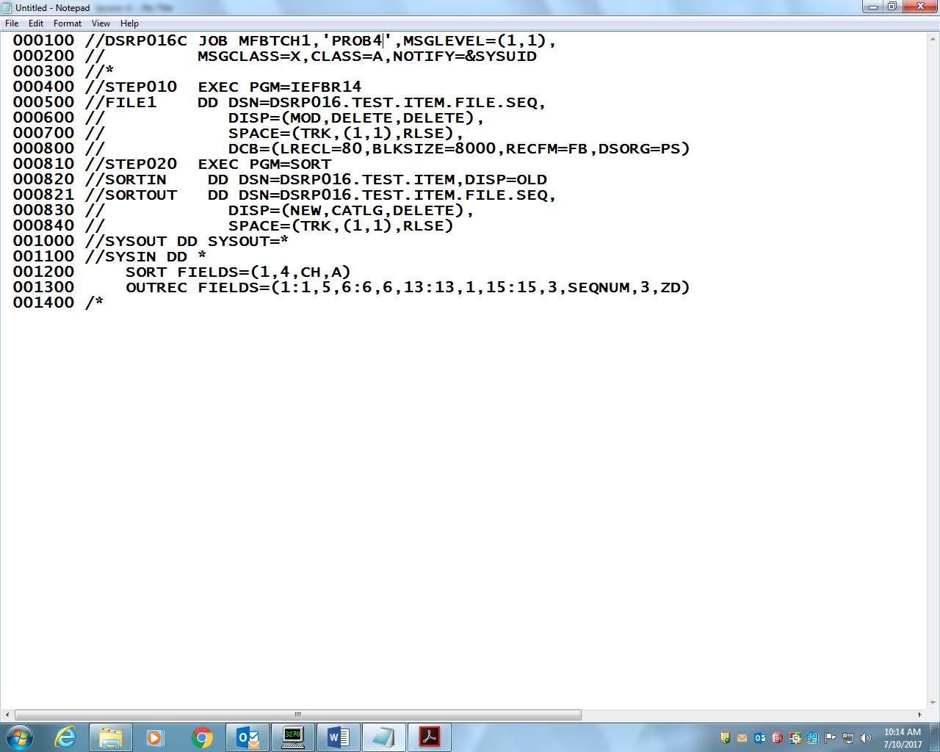

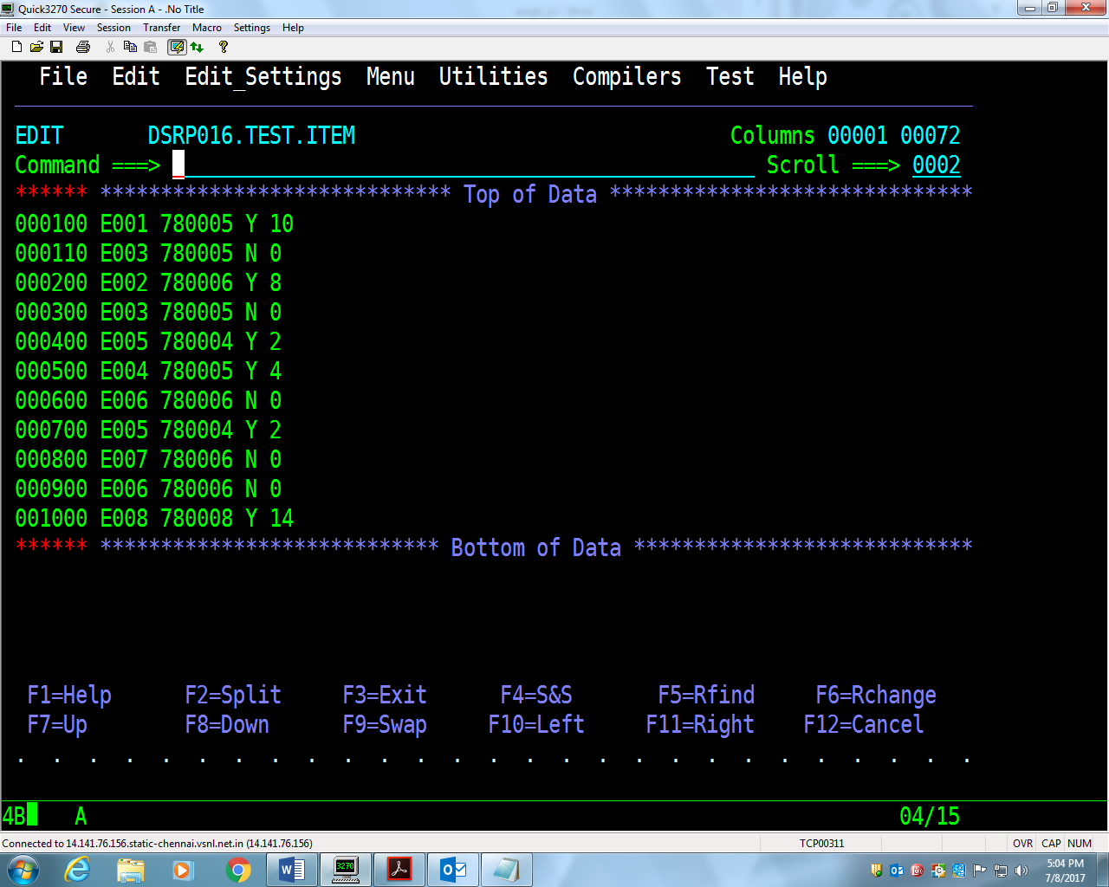

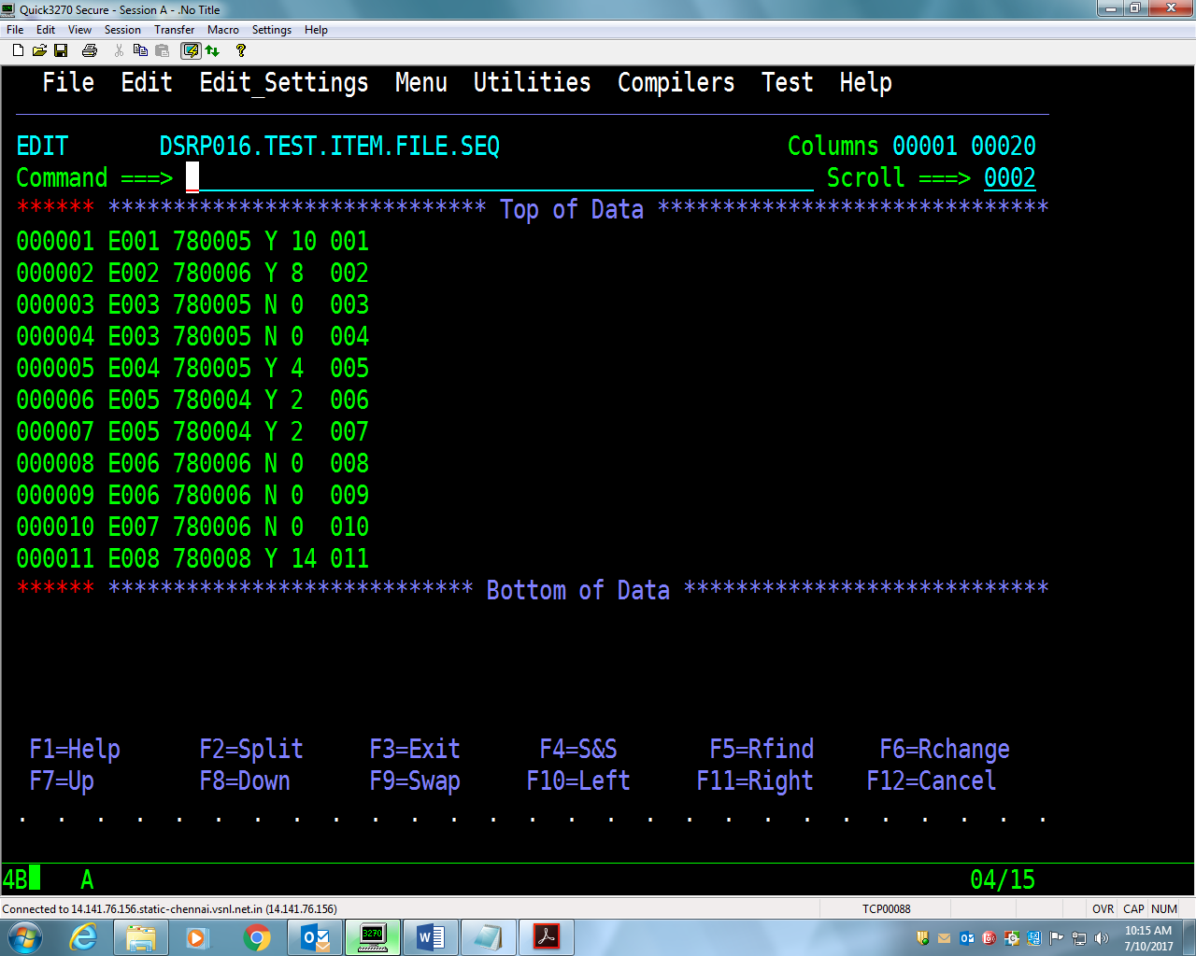

**Assignment-5:** Taking above **Item-File** as input, write a JCL to create another file

(ITEM-FILE-REV) having same records in reverse order of sequence number using

**SORT** utility. (Use **INREC** and **OUTREC**)(INREC)

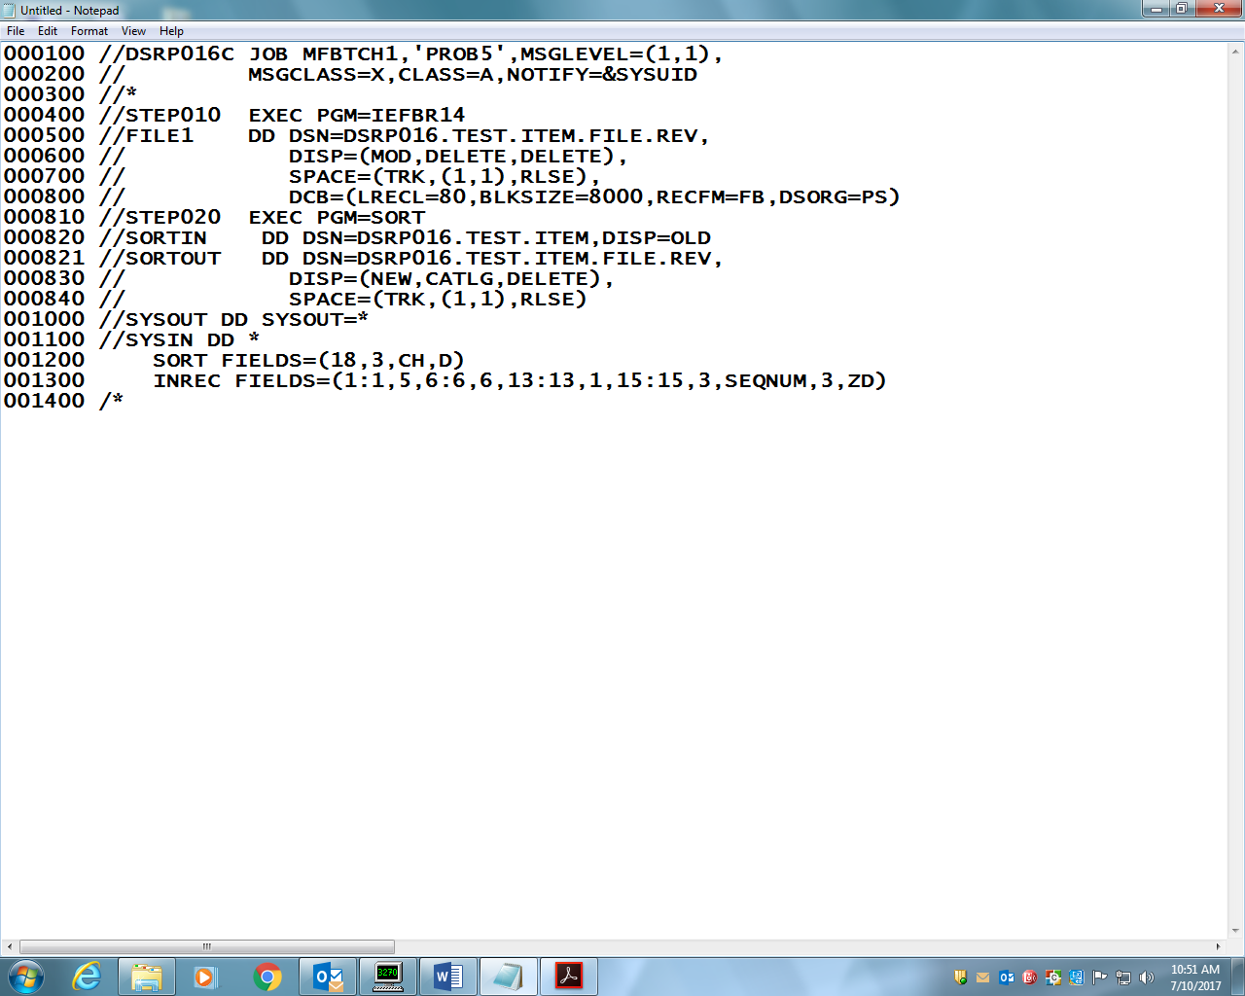

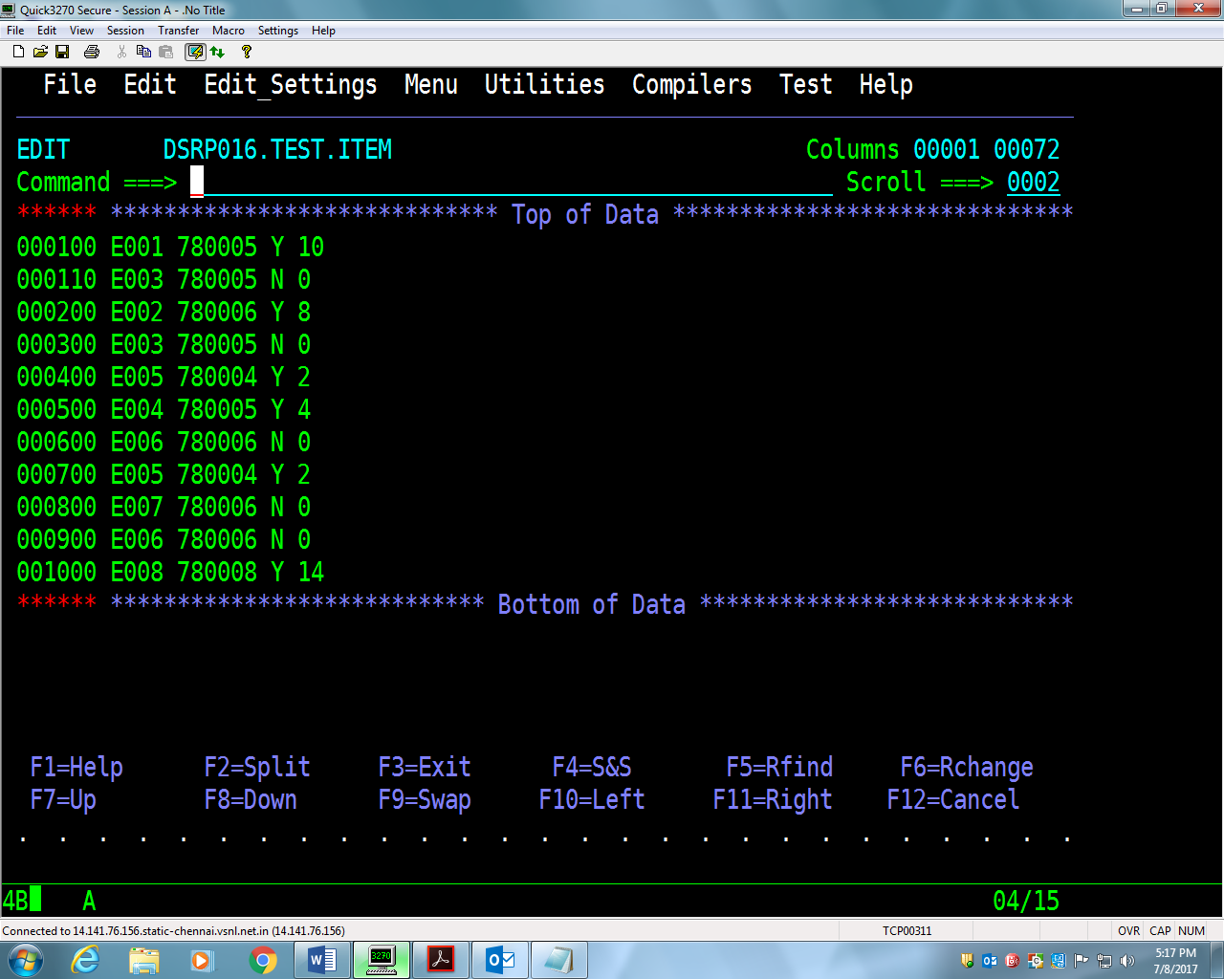

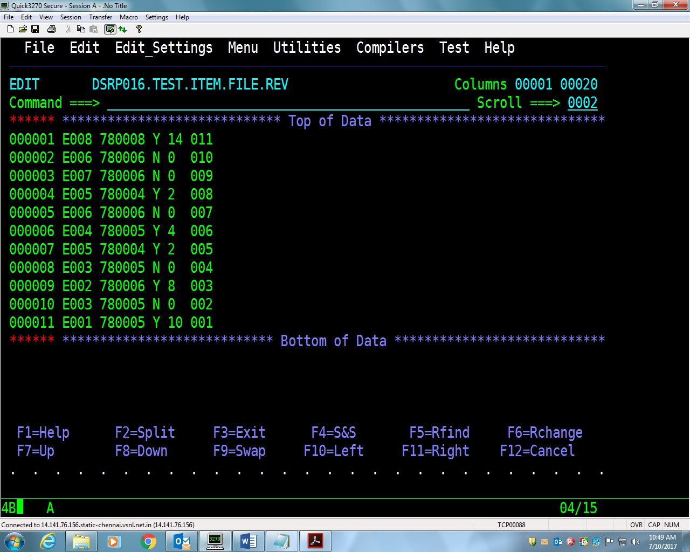

**Assignment-5:** Taking above **Item-File** as input, write a JCL to create another file

(ITEM-FILE-REV) having same records in reverse order of sequence number using

**SORT** utility. (Use **INREC** and **OUTREC**)(OUTREC)

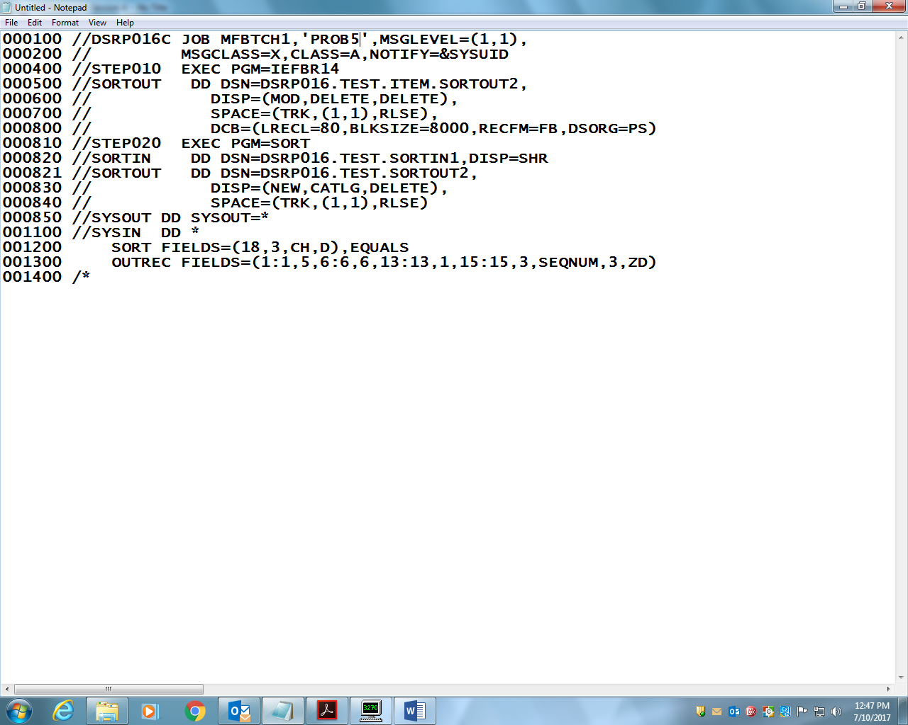

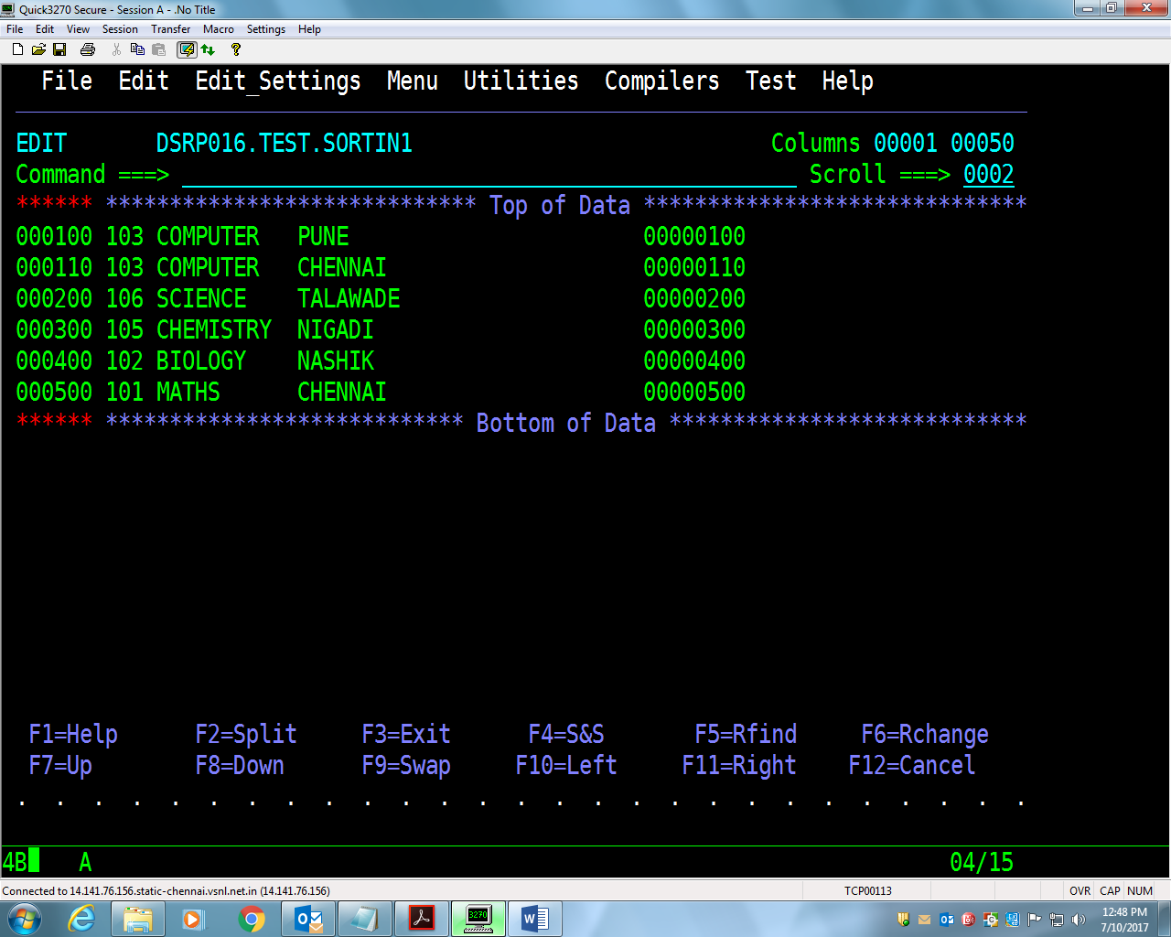



**Assignment-6:** Considering the file created in Lab 5, that is ITEM-FILE, as input,

write a JCL to concatenate these two files into a single file (ITEM-CONCT_FILE)

lengths using **IEBGENER**

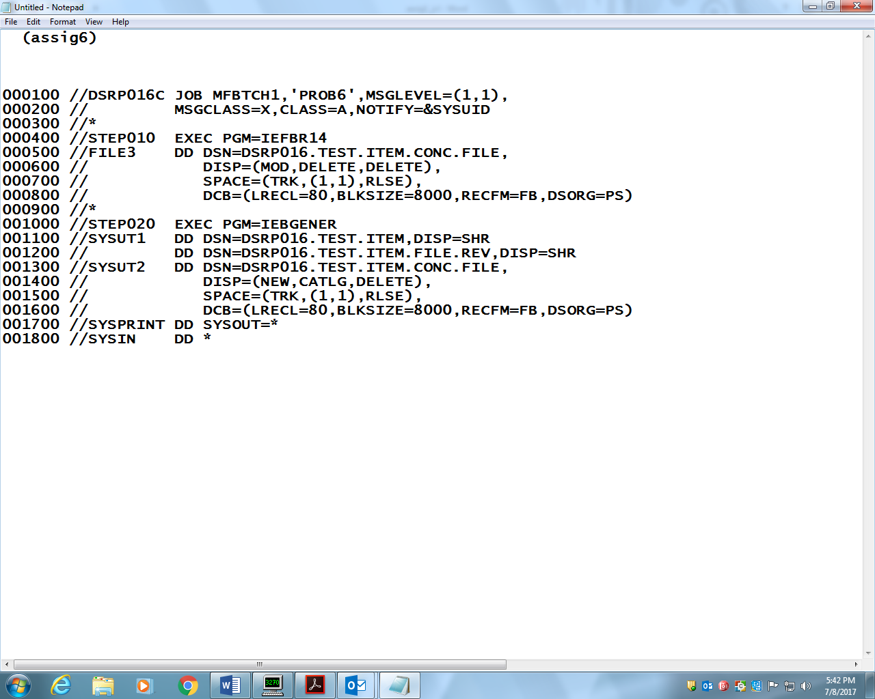

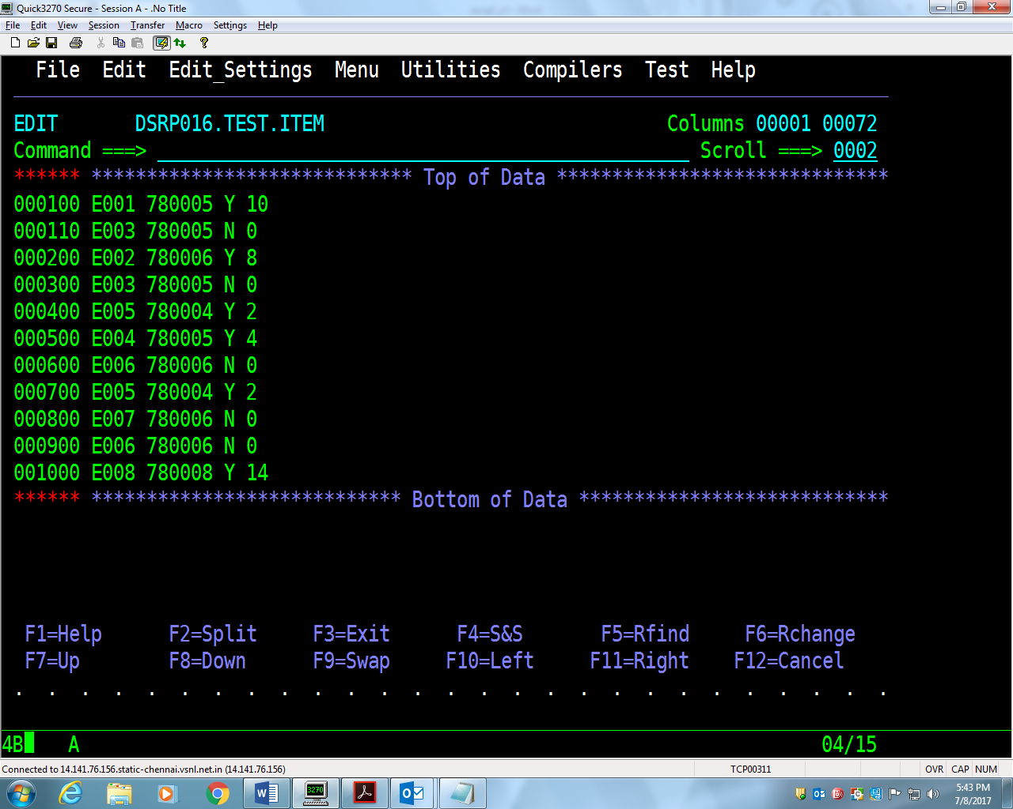

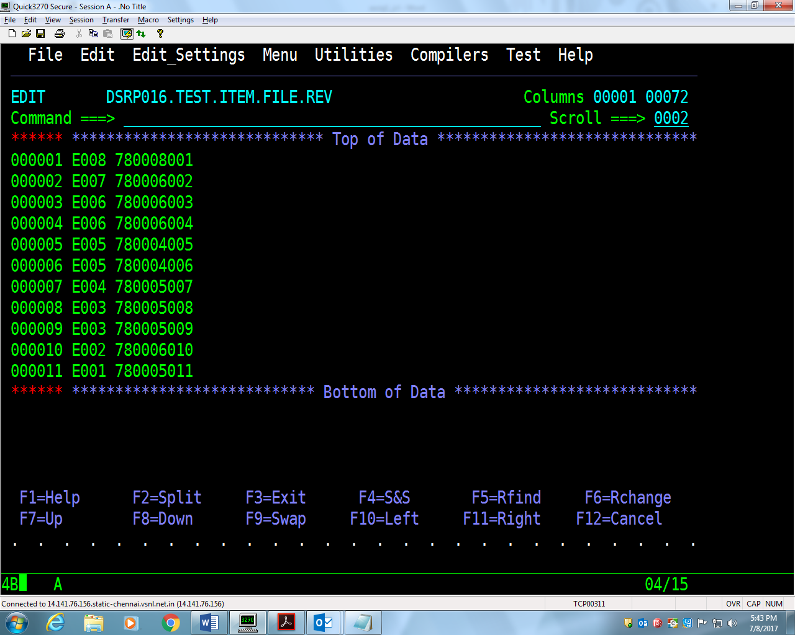

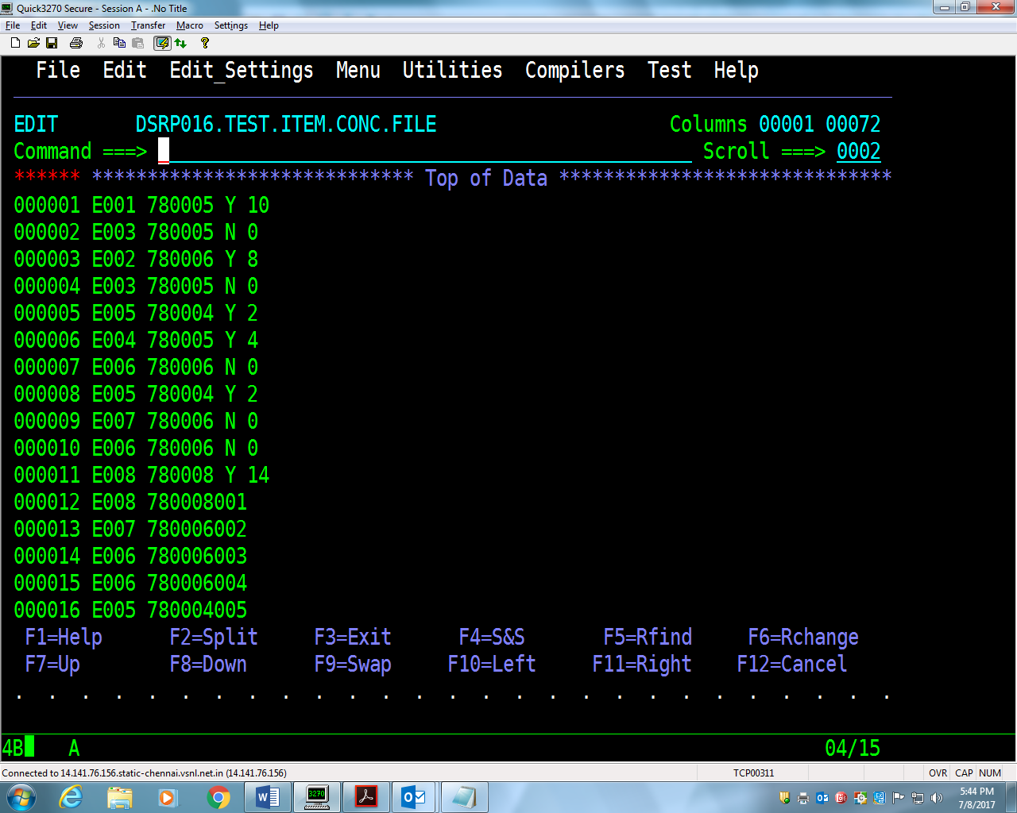

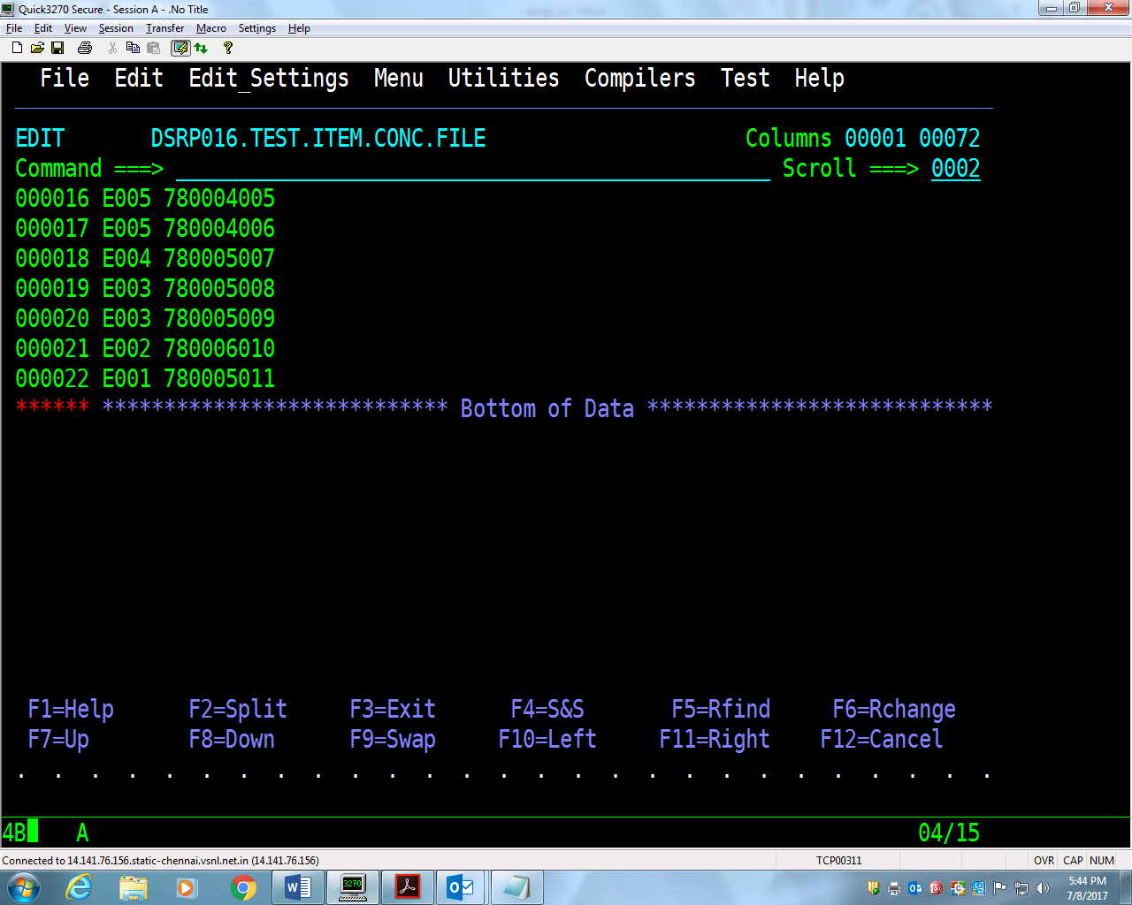

**Assignment-7:** Taking above **Item-File** as input, write a **Job** to skip the first 3

records and copying next 4 subsequent records into a new dataset (ITEM-FILE-4R)

using SORT utility.

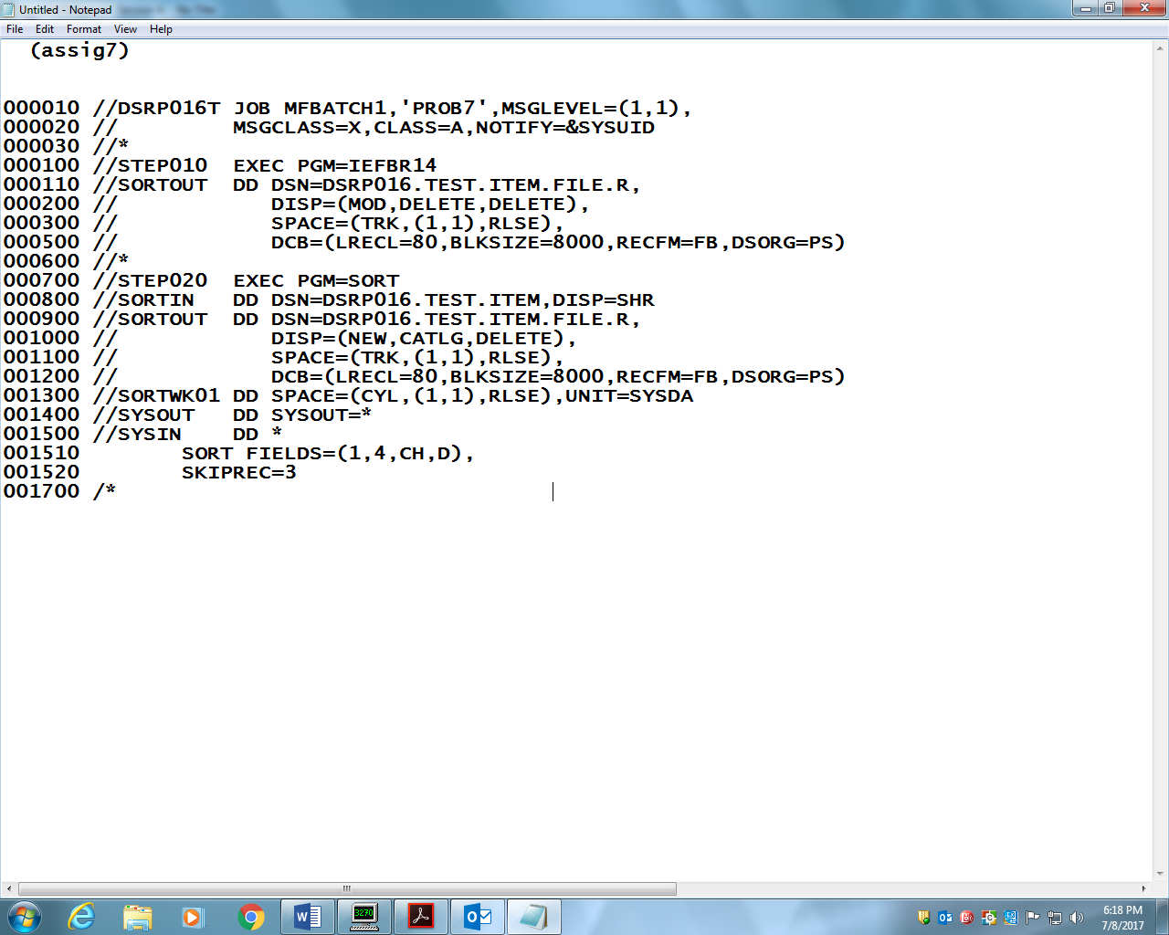

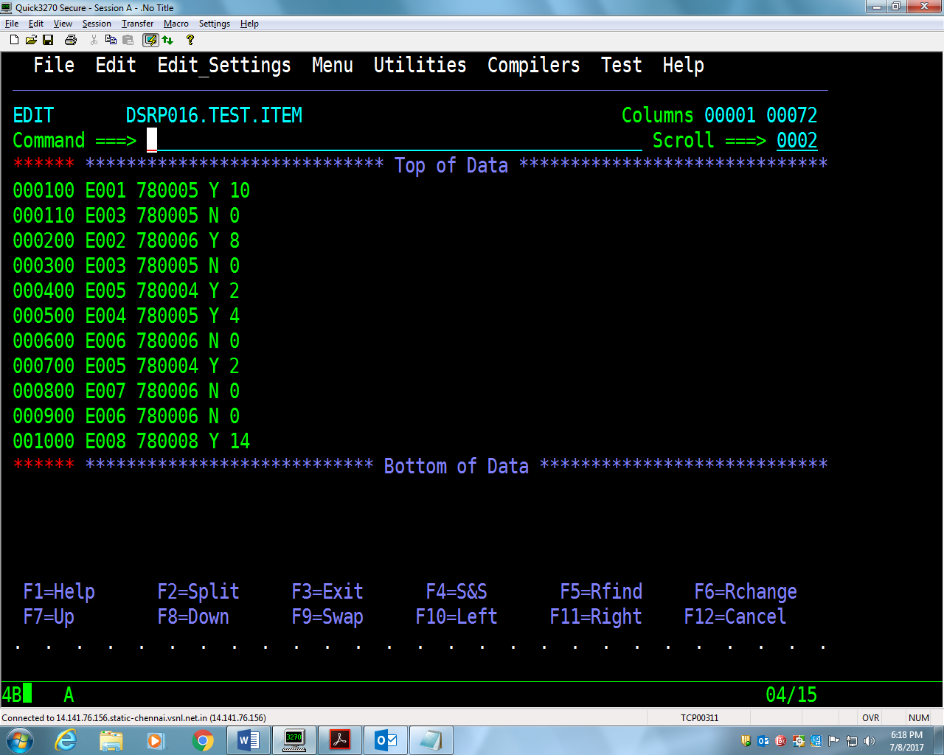

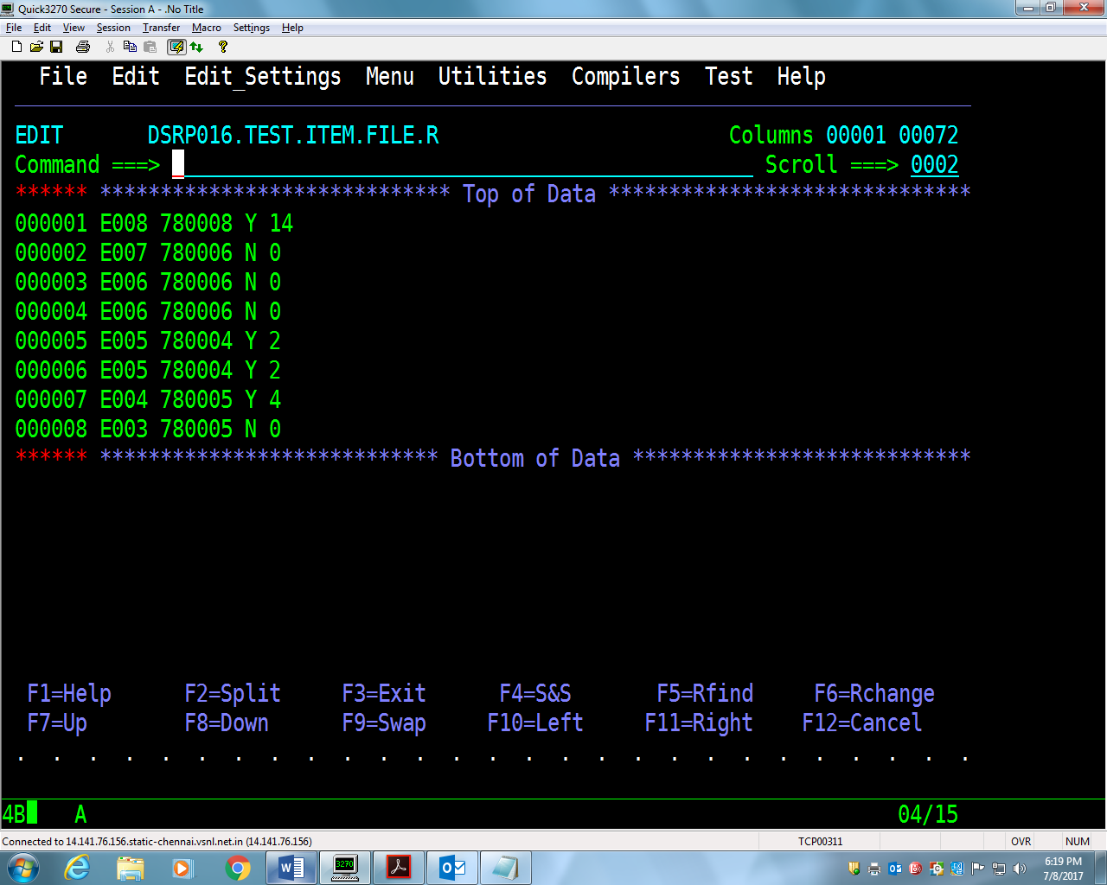

11.Write a JCL that will create new PDS USerid.MyPDS and will be cataloged on

successful execution of the step and dataset will be deleted if job terminates

abnormally.

